Contents

Scenario 2

What do you need 2

Data setup 4

Excel 4

Dataverse 4

Lab 1: 4

Excel Data to Apps 4

Scenario 4

Import Excel to Dataverse and create a Canvas app 4

Recap 9

Lab 2: 9

Use Low code plugins to enable useful components 9

Create Reusable User Defined Formulas 10

Input validation & custom errors 16

Advanced Scenarios 19

Lab 3 19

Invoke stored procedures from a Canvas App 19

Scenario 19

What is a Virtual Action Stored Procedure? 20

Stored Procedures 20

Actions, Custom Actions, and Virtual Actions 20

Power FX and Virtual Actions 20

Create the Virtual Action Stored Procedure 21

Add your virtual stored procedure to your Canvas App 26

Recap 27

Lab 4 27

Send in-app notifications with Power Fx 27

Lab 5 30

Enable real time chat on orders and include the chats in the timeline 30

Enable Teams chat and sync 30

Create a new connected chat 31

View the chat in the timeline 34

Recap 35

Lab6 36

SendEmail upon Order Creation 36

Scenario 36

Set up an Automated Lowcode plugin – Send an automated email upon a dataevent 36

Recap 42

Build Lab

Apps and Hyperscale

In this lab, you will be getting hands-on experience with a number of features that will enhance your data experiences. You will be:

* Importing an Excel file that will be converted to tables and a canvas app through the use of AI
* Using Dataverse Actions to configure in app notifications
* Create actions that will allow you to invoke a SQL stored procedure from within a canvas app
* Enable in-app chat for Dynamics 365 Sales apps
* Advanced Scenarios that you can test if you would like

## Scenario

Contoso Solar Panels is a small company that is starting to grow. They currently use Dynamics 365 to manage their sales, but their installation department still relies on Excel to schedule appointments. They do have some data stored in SQL including employee information. They used stored procedures to help calculate the best technician to send for appointments. They are looking to modernize their installation experience and integrate their experiences more cohesively.

## What do you need

To participate in the lab, you will need to have the following:

* Make sure you are in ‘Developer environment’. To check go to Environment picker on top right corner and check for the environment name similar to the credentials that is assigned to you.
* Dataverse Accelerator app
* An Excel file that provides order data that will be converted into a Dataverse table and app (for //Build this is provided for you)
* Dataverse

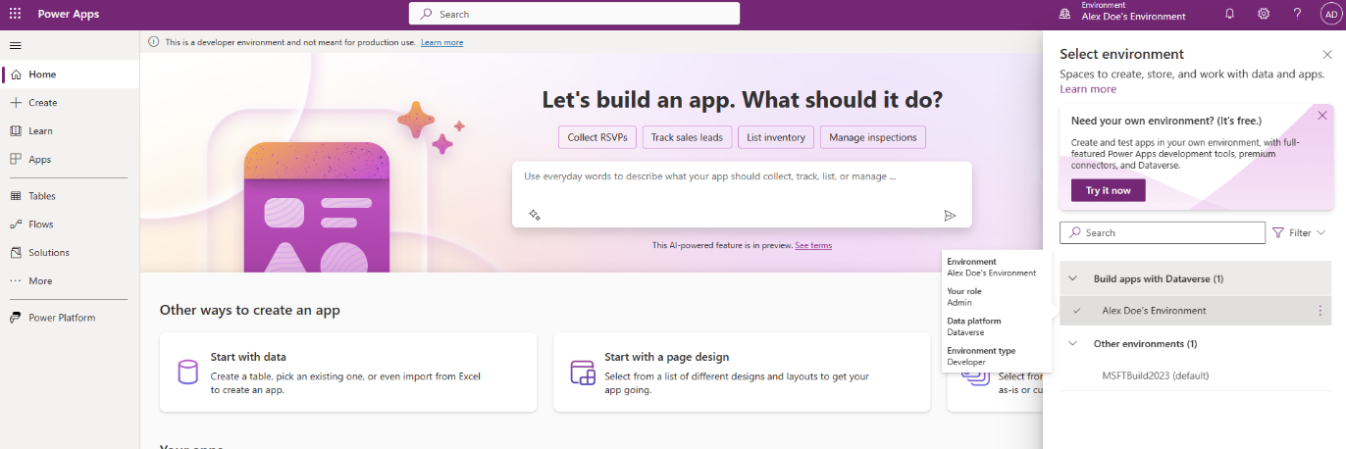

Once you login to the environment, Go to Home>Apps>Dataverse Accelerator app

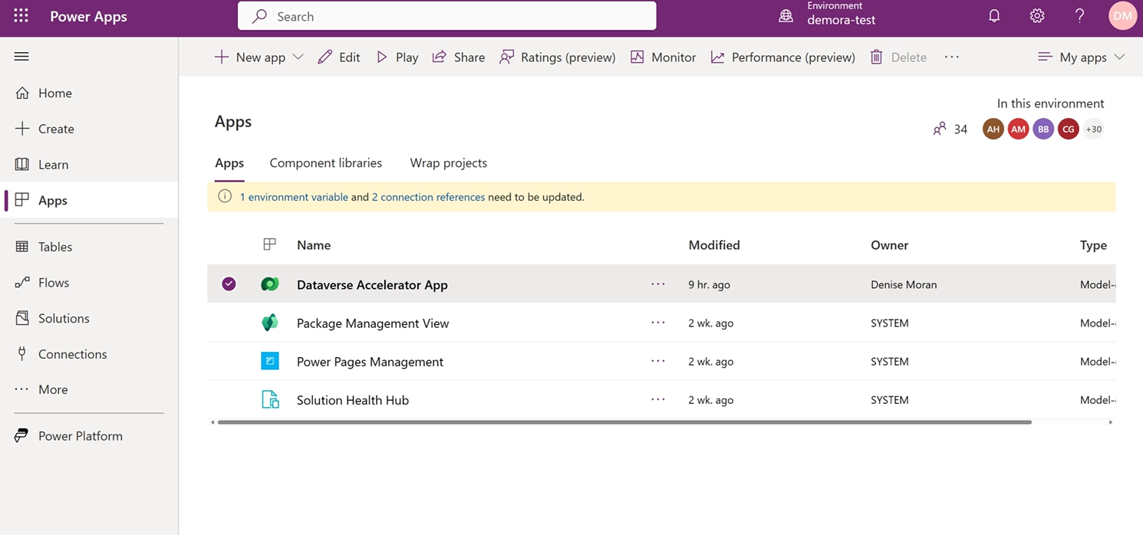

Click on the pop-up ‘Power Apps for Makers’ **Allow**

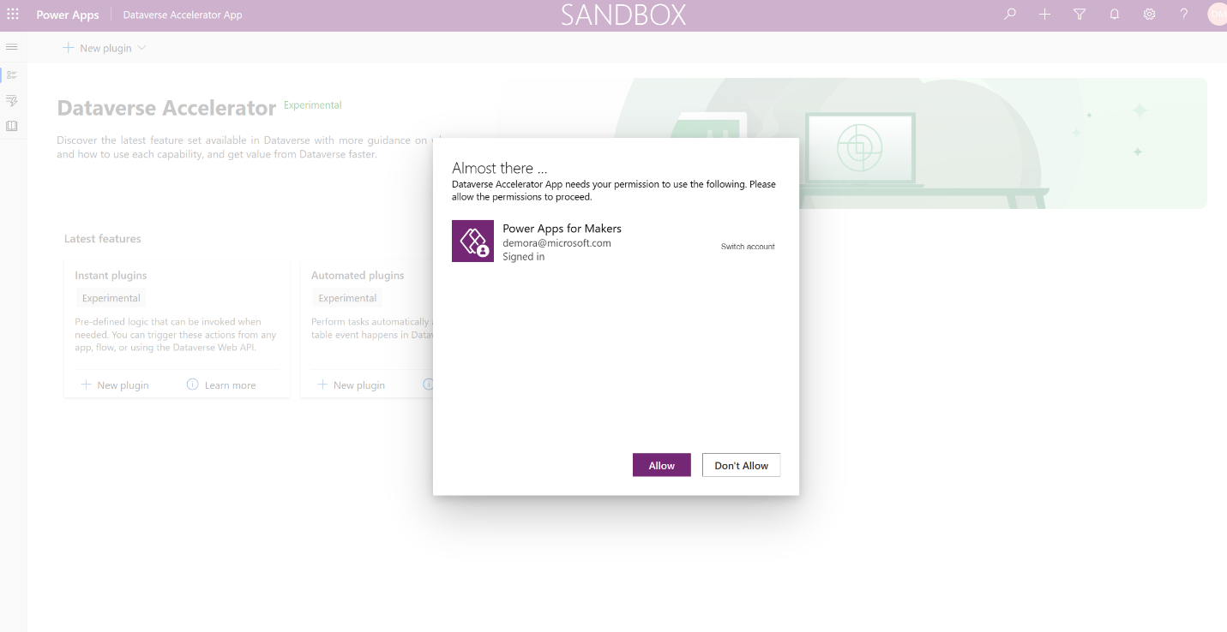

## Data setup

For the labs in this document and the demos the following is needed:

### Excel

You will use the provided Excel file, the file is available locally in your desktop Build2023-HOL-ContosoSolarPanel.xlsx

### Dataverse

You will use the data provided by the Excel file

# Lab 1:

# Excel Data to Apps

In this lab you will need your Dataverse environment and the Excel file provided.

## Scenario

Mona is a developer for Contoso Solar Panels and has been asked by her boss to modernize their current installation process using Power Platform. Contoso currently does all their installation scheduling in Excel. She wants to migrate the data into Dataverse and create a canvas app that can be used to handle installation scheduling. She sees that Power Apps has a new feature that will let her choose her excel file, and using AI it will generate a Dataverse table and an app, and complete the migration automatically.

## Import Excel to Dataverse and create a Canvas app

1. Go to [https://make.preview.powerapps.com](https://make.powerapps.com) and use the provided login.
2. From the Home page of Makers portal, toggle to turn on **Try the new Power Apps**. Then, click on **Start with Data** button.  
   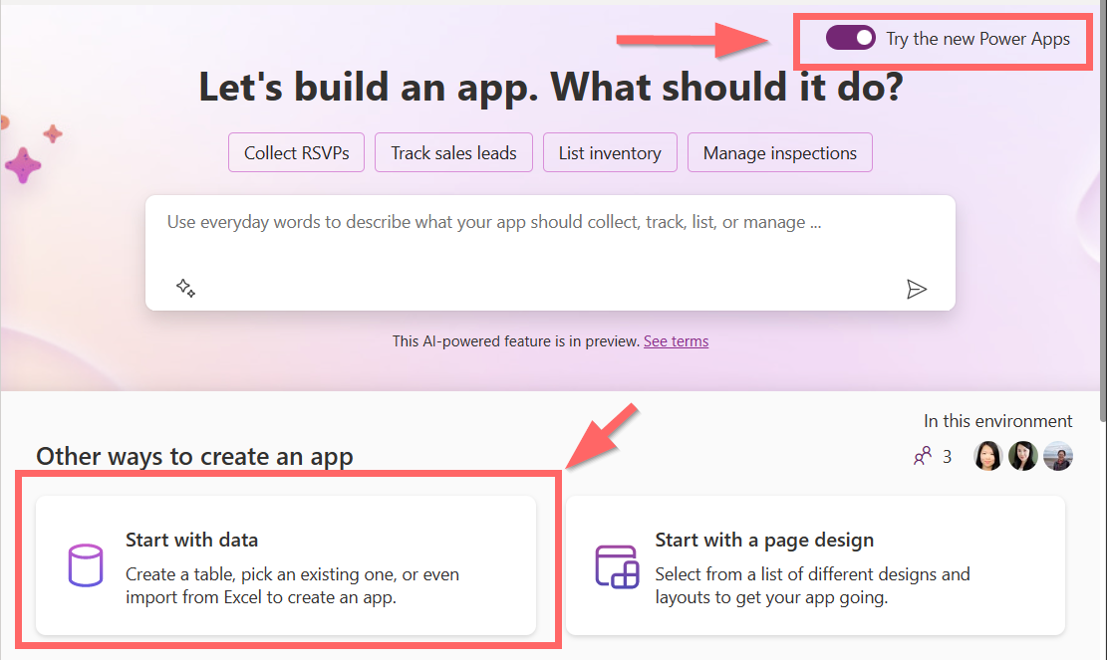
3. Choose **Upload an Excel file** on the **Create an app** screen.
4. Drag and drop the Excel file that you have downloaded from the Data Setup: Excel section earlier in this document.
   1. The preview will show 20 sample rows from the Excel file and AI will generate: Column data types, Table Display Name (including the Plural Name and the Schema Name). You can modify the suggested AI-generated column data types and table display name in the preview.

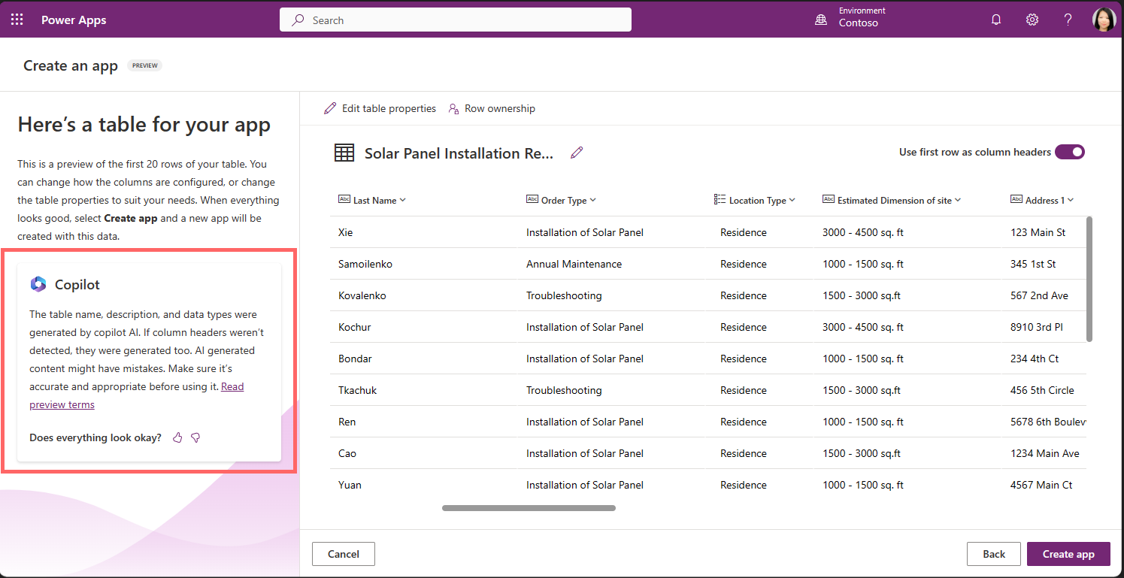

**TIP**: When Copilot AI is being applied to the preview, the Copilot notification will show on the left hand pane.

1. Ensure that **Use first row as column headers** is set to On, to allow the first row to be used as a header. By default, the feature will detect if there is a header and will set this setting to On.   
   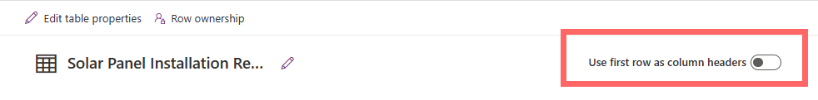  
   **TIP:** outside of this Lab, if your file does not contain any header, you can set **Use first row as column headers** to Off, and AI will suggest the column names as well.
2. Navigate to the *Location Type* column and click on the down arrow icon, and click on the **Edit column**. Ensure that the column *Location Type* is set to *Choice* as the data type. In the selection, you will see that only one value “Residence” shown as one choice. When the data is imported, the remaining choice values will be added automatically per what’s available in the dataset.

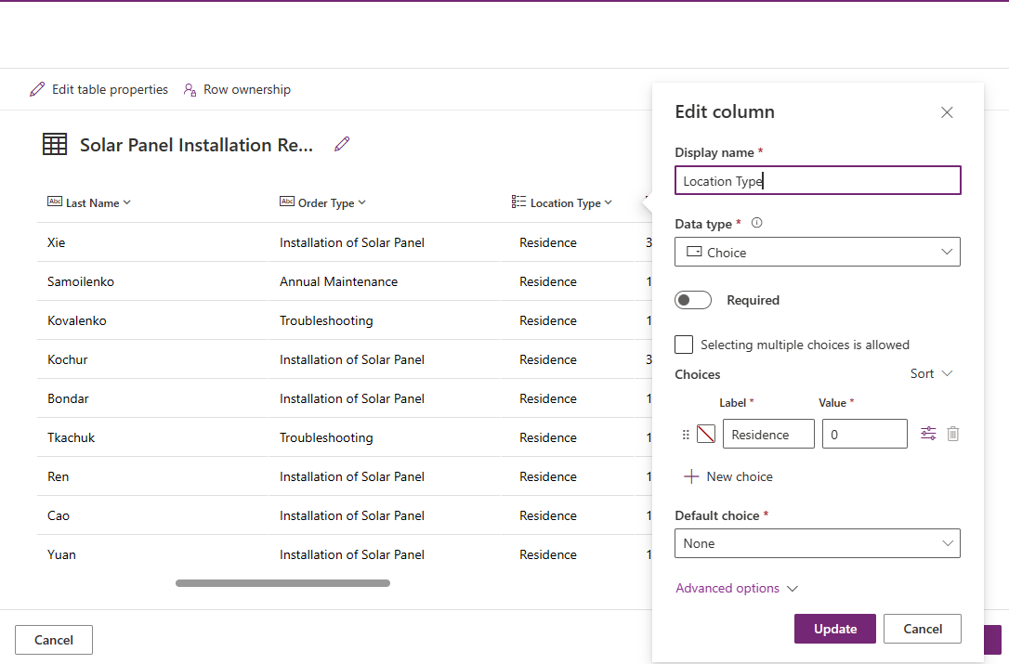

**TIP:** it is possible that AI does not suggest the data type to be *Choice*. You can set this manually, and Choice of “Residence”, “Business” and “Apartment”.

1. Using the pencil icon next to the table name, rename the table to: “Service Order”.   
   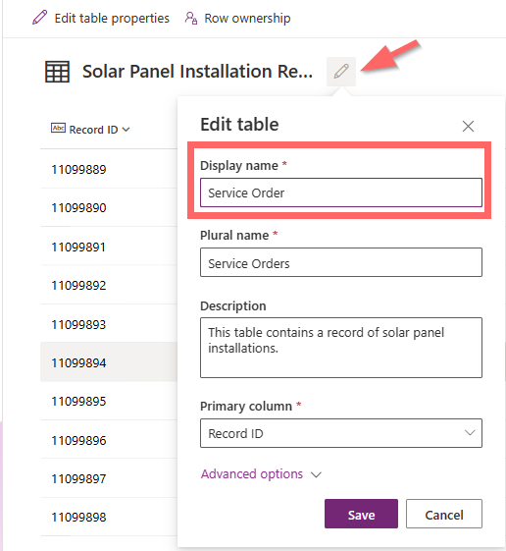
2. Review the **Row Ownership** from the preview page, and make sure that “Rows owned by a user or team” is selected.   
   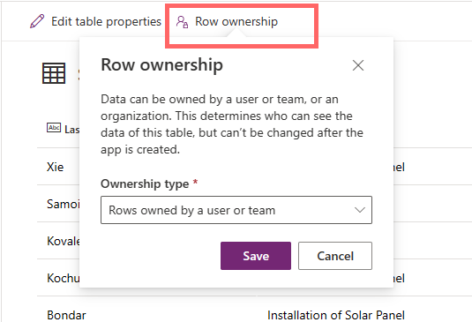
3. Click the **Create App** button on the bottom left corner to start creating a new table in Dataverse, importing the data from Excel into the new table, and creating a Canvas app.
4. Now you can review the Canvas App in edit mode and click **Play** to start the app.  
   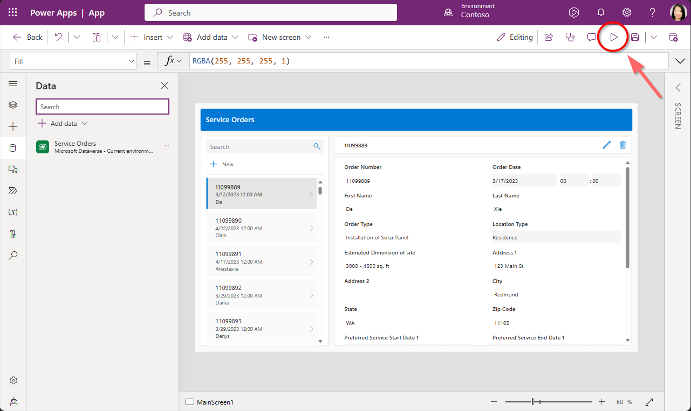

## Recap

Mona was able to use the Excel to App feature which uses existing Excel files, and processes them using AI to determine the table name and description, column names (and suggests some if they are not present as a header in the table), data types, and provides an overview of how it looks. After accepting this an App is generated based on this table. This can all be done with a simple drop of an excel file and a confirmation, no additional effort was needed.

# Lab 2:

# Use Low code plugins to enable useful components

**What are Low code plugins?**

Lowcode plugins are reusable, server-side synchronous (‘real-time’) business logic workflows that allow you to execute a set of specific commands in Dataverse, called from web services (like the Dataverse connector or the web API). They can be defined with the Power Fx expression language. They have access to almost all the same functions that are available in canvas apps.

**What can low code plugins do?**

* Perform Dataverse CRUD operations (using Power Fx)
* Access other tables in the environment:
  + LookUp( <TableName>, <condition> )
  + Patch( <TableName>, <Row>, { <Updates> })
* Instant actions can accept input and output parameters
* Call other actions (that have been activated, like SendAppNotification)

# Create Reusable User Defined Formulas

Although this is not related to the Solar panel scenario, did you know that you can now define UDFs that can be reused across the apps? Let’s test this out!!

Open Dataverse Accelerator app

1. In the first card, click “+ New Instant plugin”

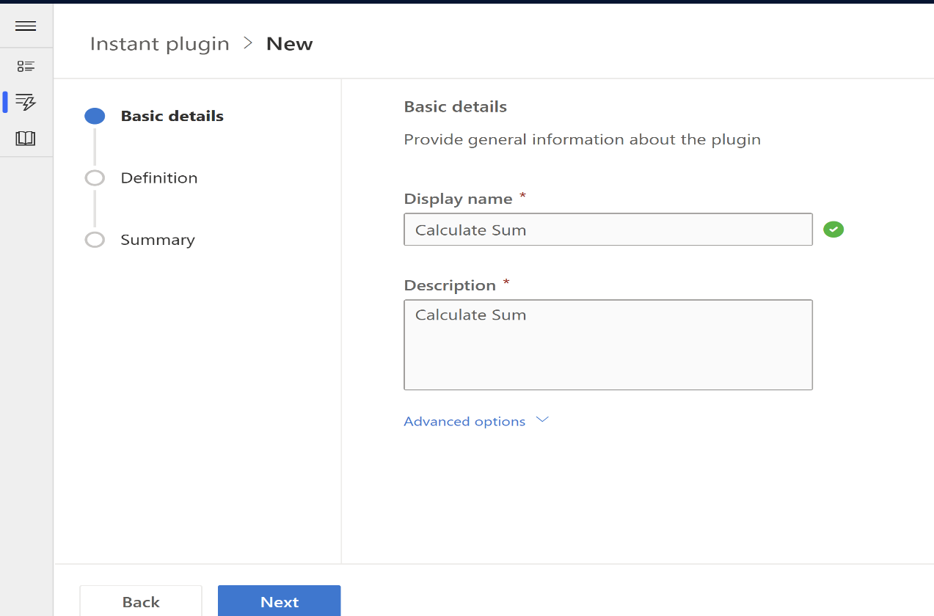

1. Provide a name and description of the plugin
   1. Example: Calculate Sum
2. Select “Next” to continue
3. Provide input parameters
   1. X (type=Integer)
   2. Y (type= Integer)
4. Provide an output parameter
   1. Z (type= Integer)
5. Enter formula
   1. {Z: X + Y }

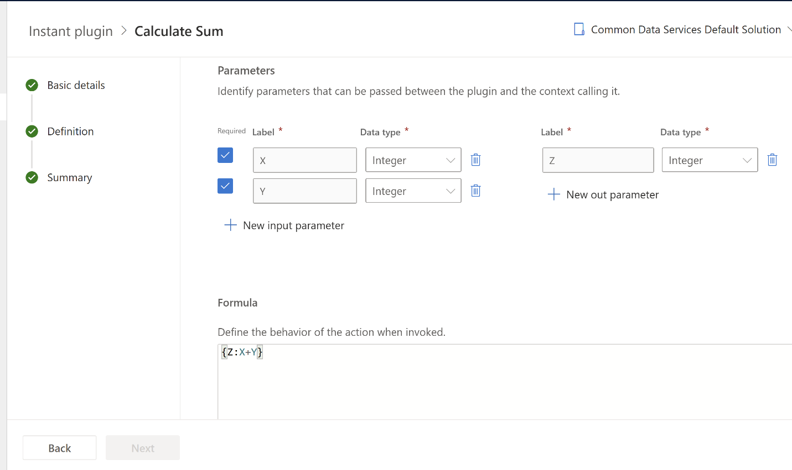

1. Select “Next” to continue. Click the ‘Test’ button

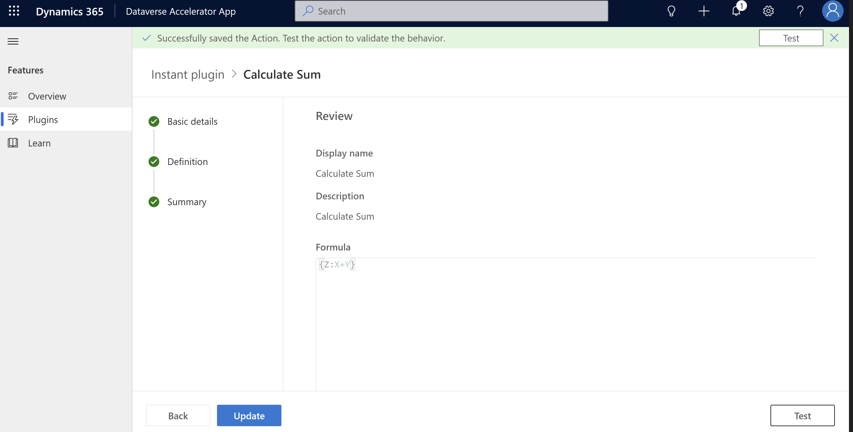

1. Input values as shown

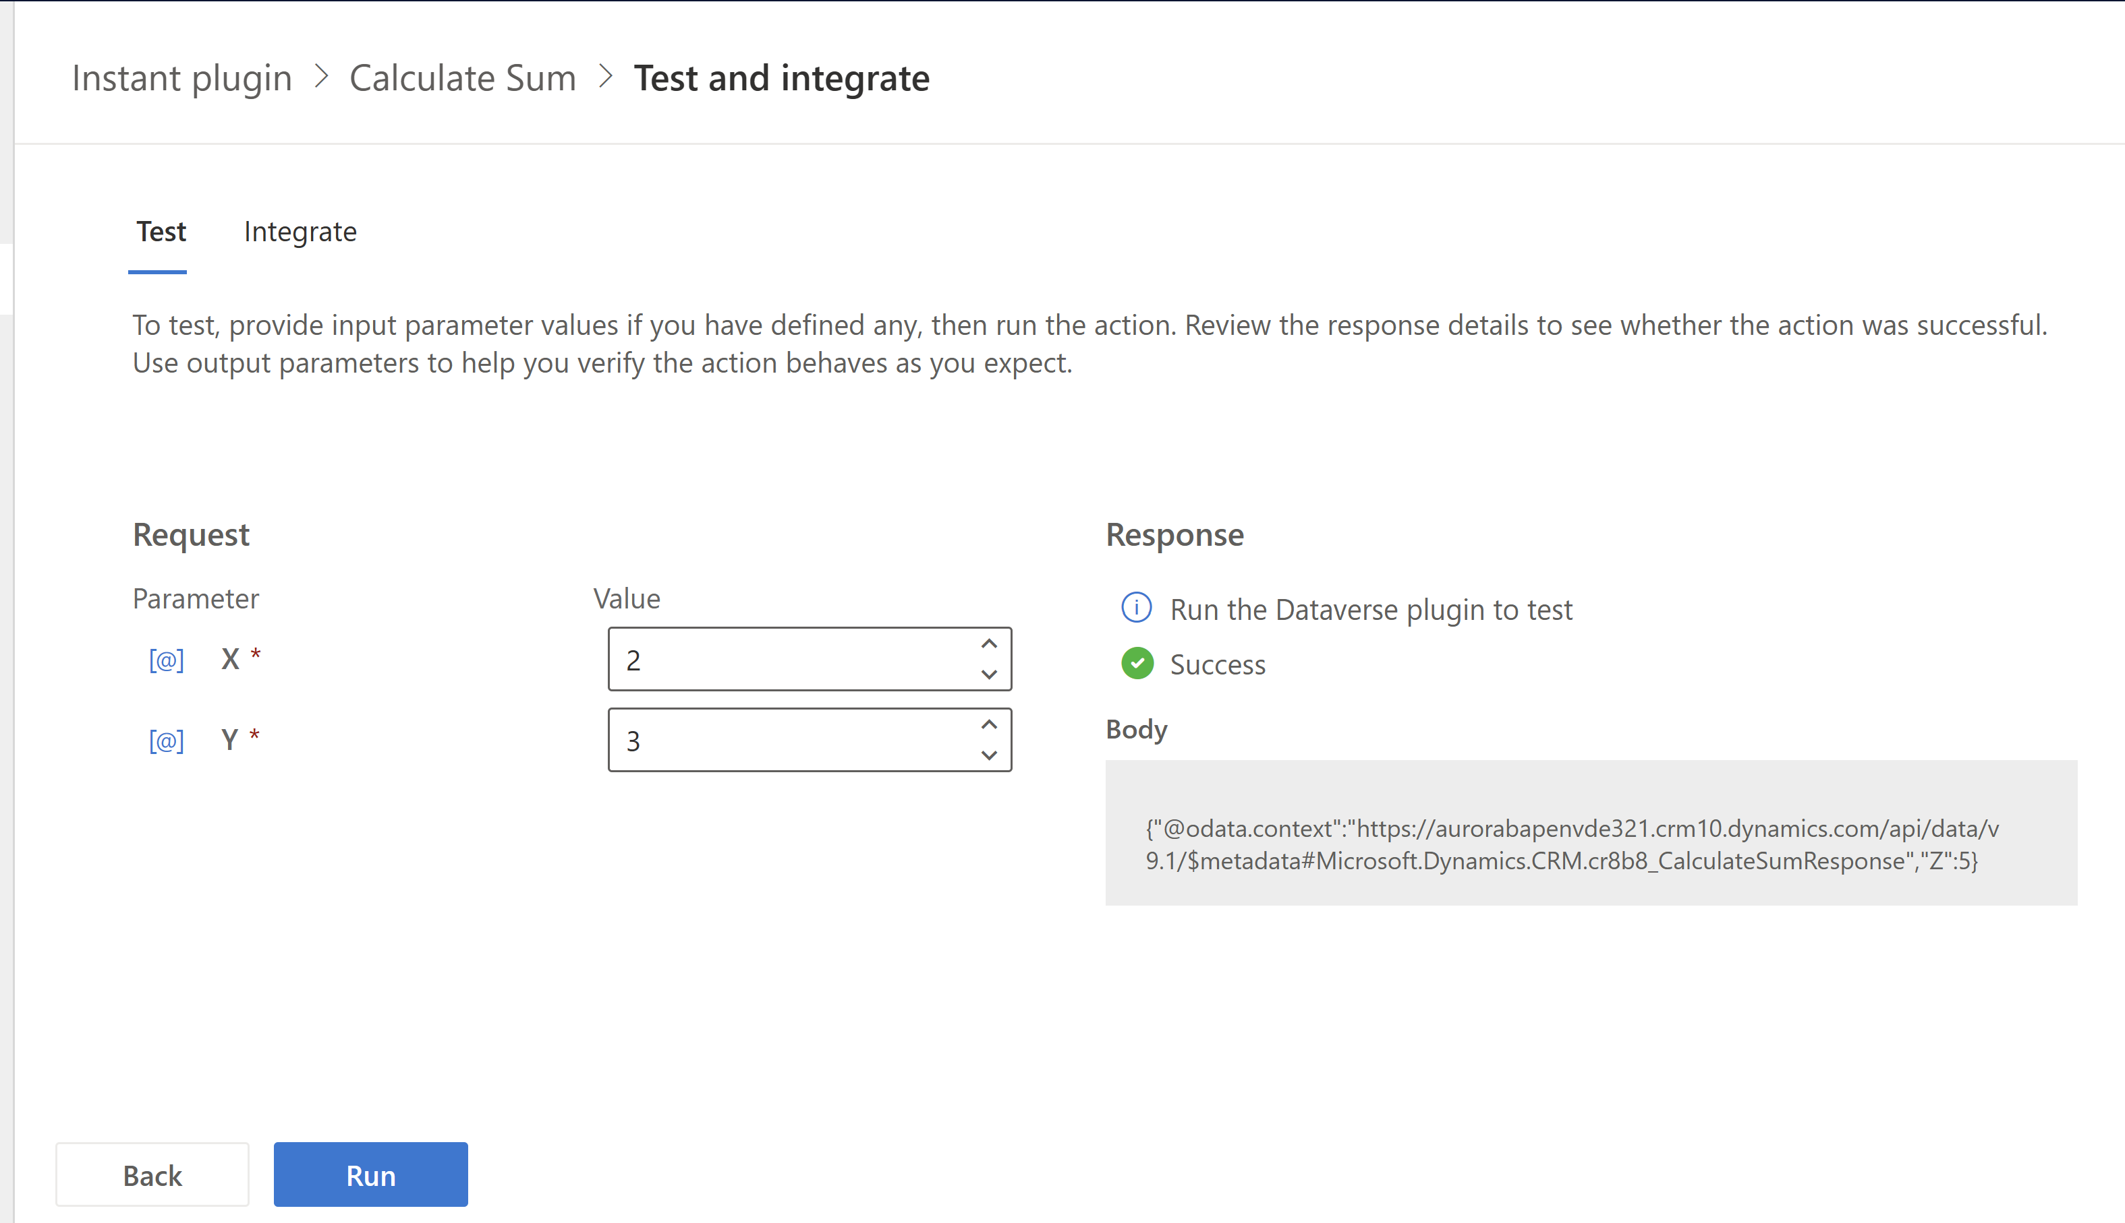

9.Click ‘Run’, you will see ‘Success’ Response and that means the formula is successfully generated

10. Click on ‘Integrate’ tab , copy the formula , we need to paste this inside the Canvas app.

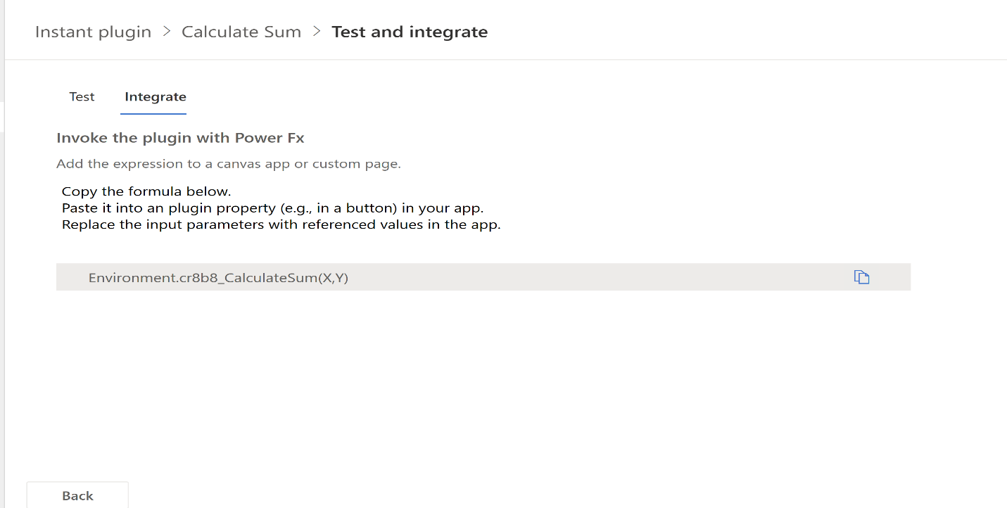

Now let’s test the instant plugin that performs mathematical calculations.

Note- In order to call these plugins as Dataverse actions, you need to enable the settings under Canvas app by following the steps here [Connect to Microsoft Dataverse - Power Apps | Microsoft Learn](https://learn.microsoft.com/en-us/power-apps/maker/canvas-apps/connections/connection-common-data-service)

11.Create a canvas app with the following layout. You can also refer the steps by following the instructions here [Create a canvas app from scratch using Microsoft Dataverse - Power Apps | Microsoft Learn](https://learn.microsoft.com/en-us/power-apps/maker/canvas-apps/data-platform-create-app-scratch#open-a-blank-app)

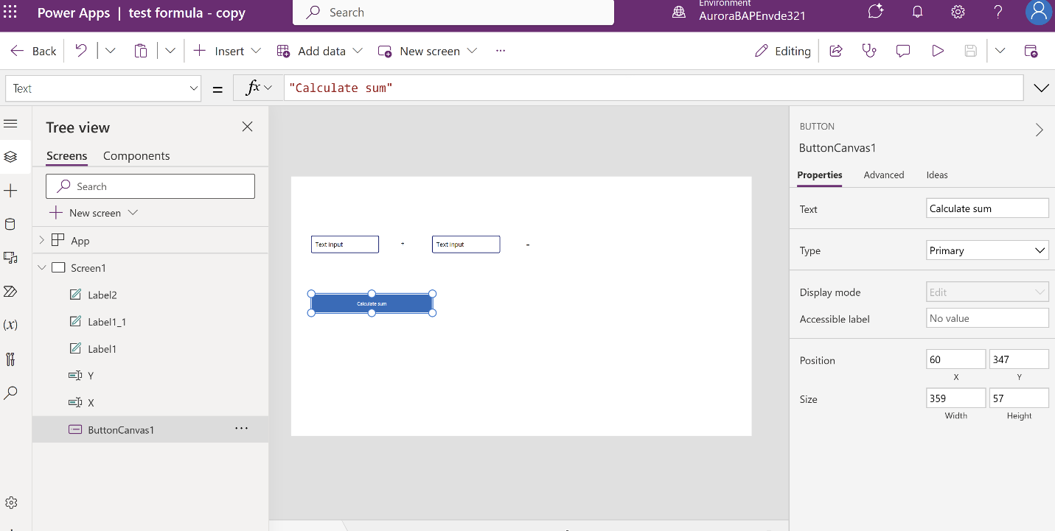

Add 2 text input controls – 1 button control and 1 label. Change the **format** property of the input controls to **number** in the ‘Properties’ tab

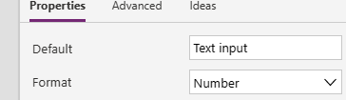

In order to call these plugins as Dataverse actions, you need to enable the settings under Canvas app by following the steps, you will need to open your canvas app for editing and navigate to Settings > Upcoming features > Experimental > Enable access to Microsoft Dataverse actions and set the toggle to On

<https://learn.microsoft.com/en-us/power-apps/maker/canvas-apps/connections/connection-common-data-service>

2.Under data, add ‘Environment’ as the data source

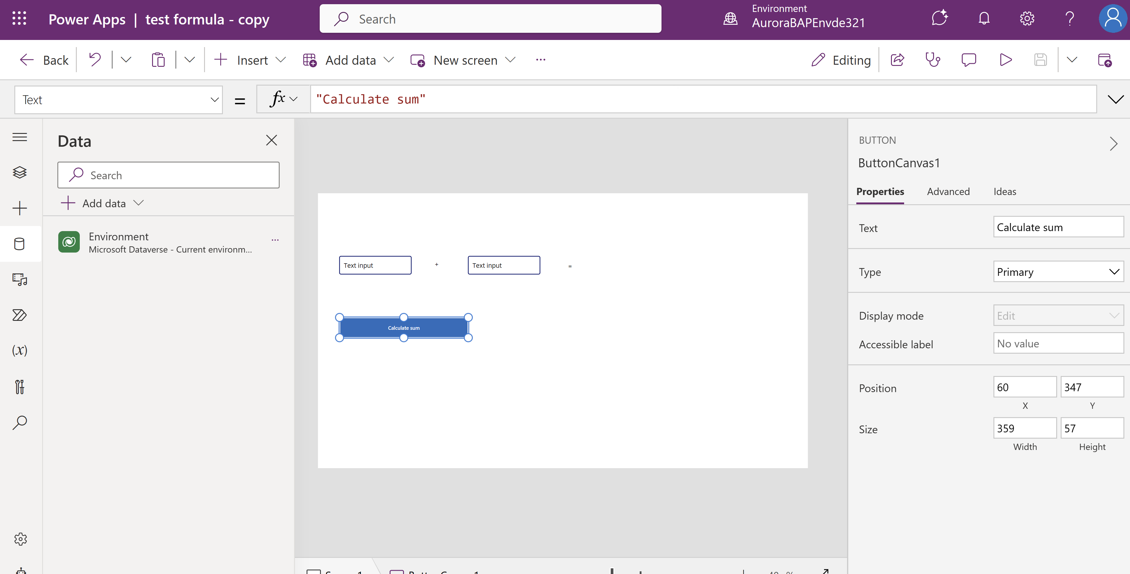

3.Paste the formula you generated from Accelerator here

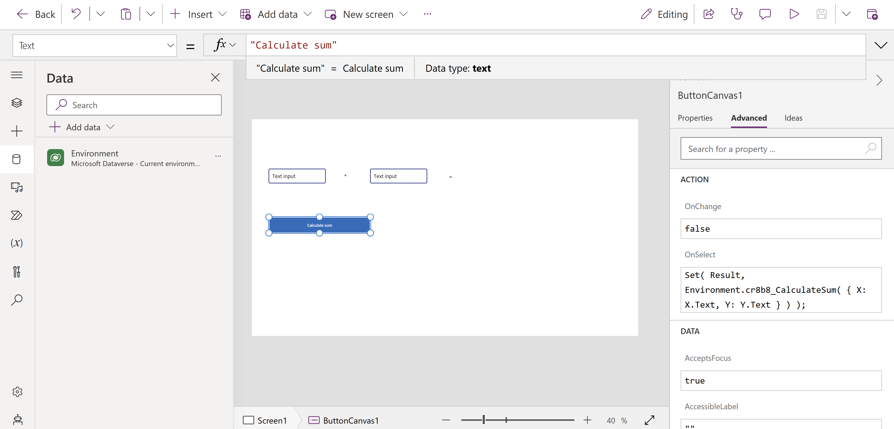

The formula will be as follows:

Set(

Result,

Environment.cr8b8_CalculateSum(

{

X: Textinput1.text,

Y: Textinput2.text

}

)

);

4.Change the text value of the label to reference **Results.Z**

4.Now run the app and you have your own personal calculator ready 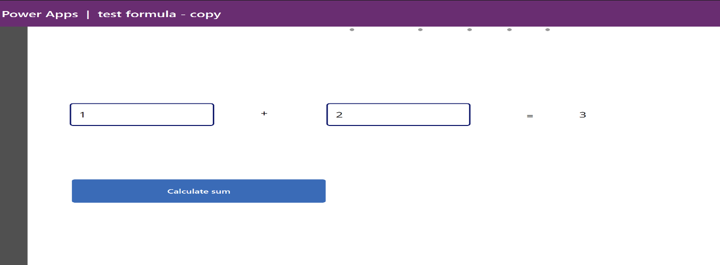

Try another formula

1. In the command bar, click “+ New action” > “Instant plugin’
2. Provide a **display name** (e.g., the formula name) and **description**
3. Create an **Out parameter** to help validate expected behavior that makes sense (string should work for most scenarios)  
   1. Optionally use input parameters to make testing easier, that makes sense with the formula
4. In the **formula** editor, wrap in the Out parameter in curly brackets:  
   {

    Out: ""

}

1. **Write an expression** that tests the formula:
   1. Validate that intellisense accepts the formula (text will turn light blue)
   2. Implement an expression that provides an output to help validate the result

{

    Out: "Abs(-5) = 5: " & Text( Abs(-5) = 5 )

}

1. Click **Next**, then **Save**

**Test** the formula (click on the test button). Use the output parameter to validate the result  
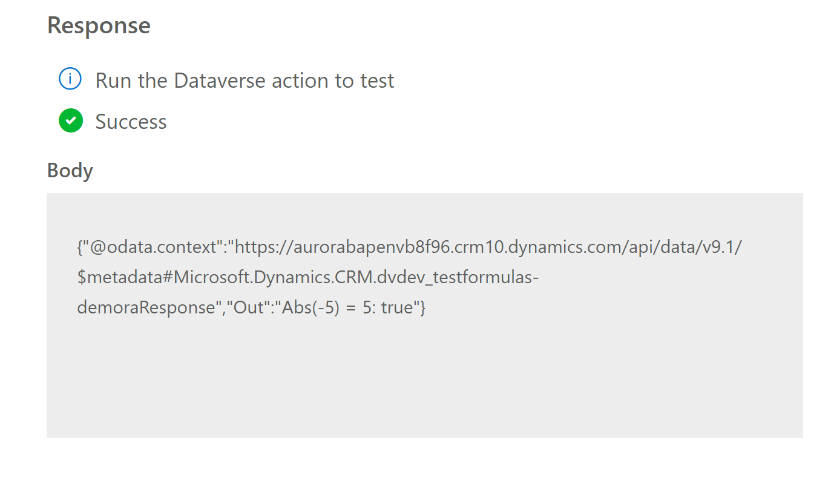

## Input validation & custom errors

Now let’s Implement server-side input validation

1. Create a new automated plugin
2. Name : **Duplicate check**
3. Select Table**: Contact**
4. Run this plugin when the row is: **‘Created’**

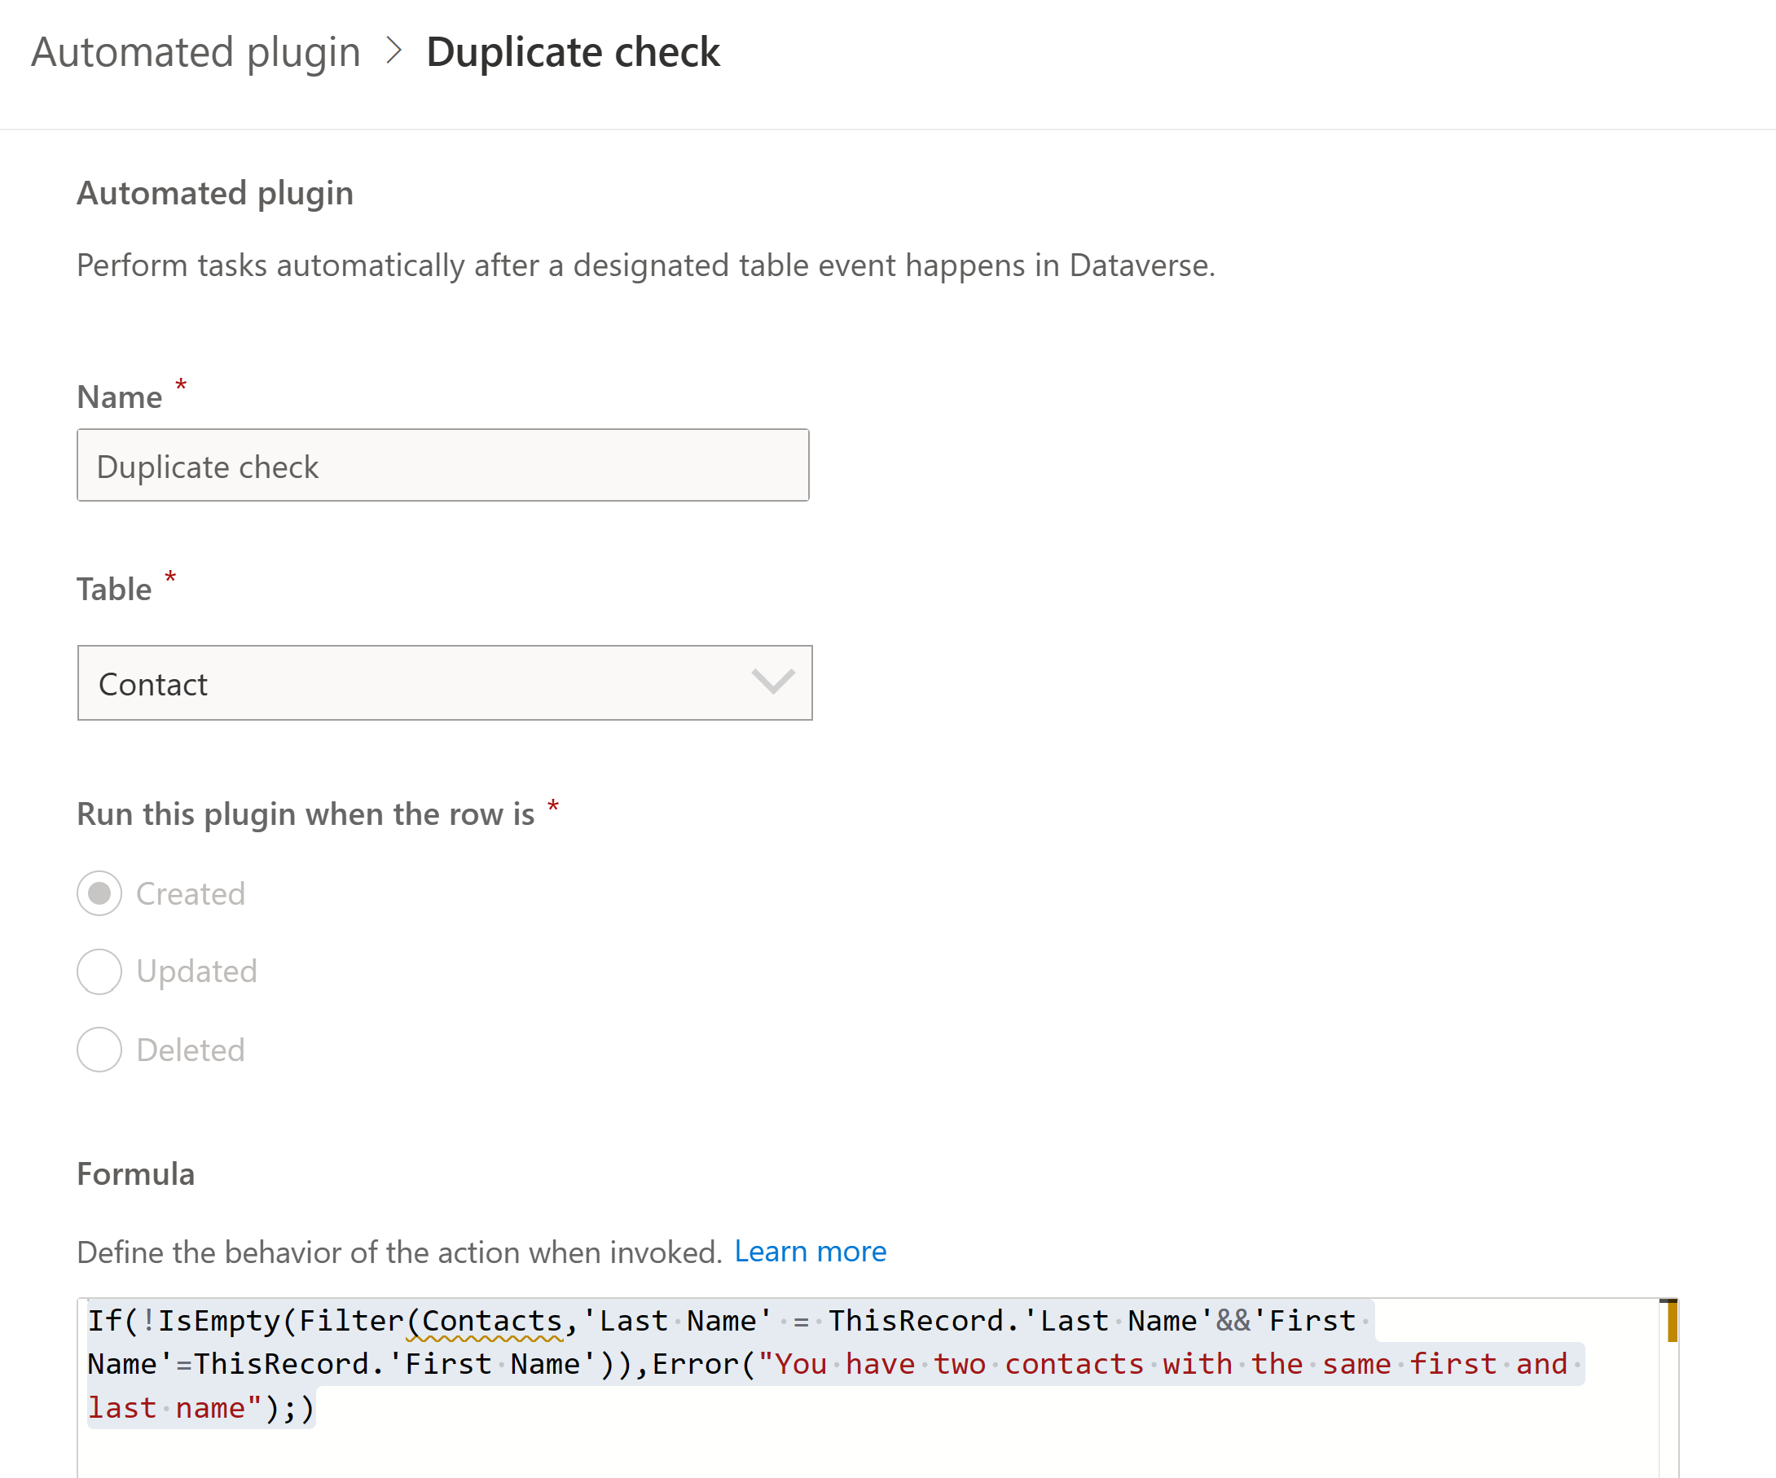

1. Enter the **formula** below

```PowerShell-nocode

If(!IsEmpty(Filter(Contacts,'Last Name'=ThisRecord.'Last Name' && 'First Name'=ThisRecord.'First Name')),Error("You have two contacts with the same first name and last name");)

1. Save

To test this, create a canvas app on the ‘Contacts’ table by following the steps listed here [Create a canvas app from scratch using Microsoft Dataverse - Power Apps | Microsoft Learn](https://learn.microsoft.com/en-us/power-apps/maker/canvas-apps/data-platform-create-app-scratch?source=recommendations#specify-a-table)

Enter Contact record as shown and click ‘Save and Close’

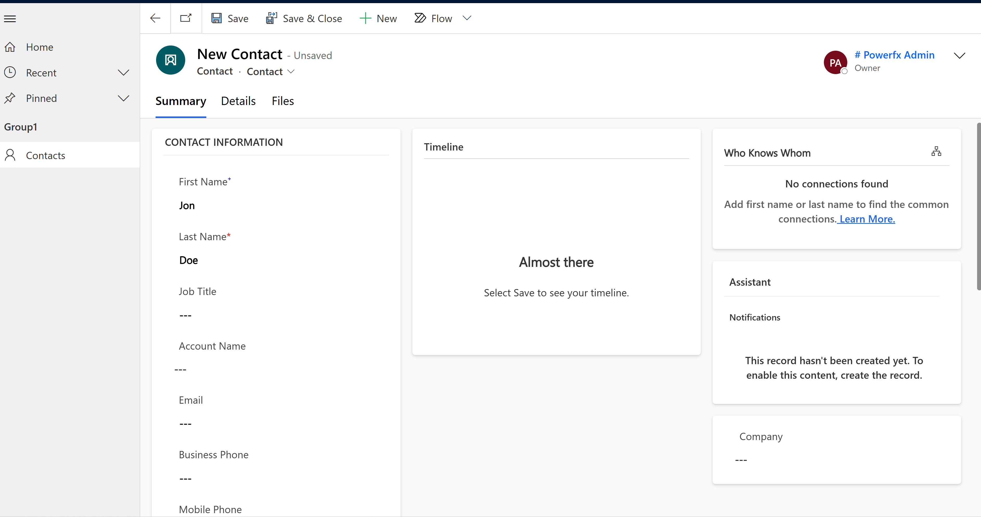

Try entering the same Contact one more time, you will now notice this error message:

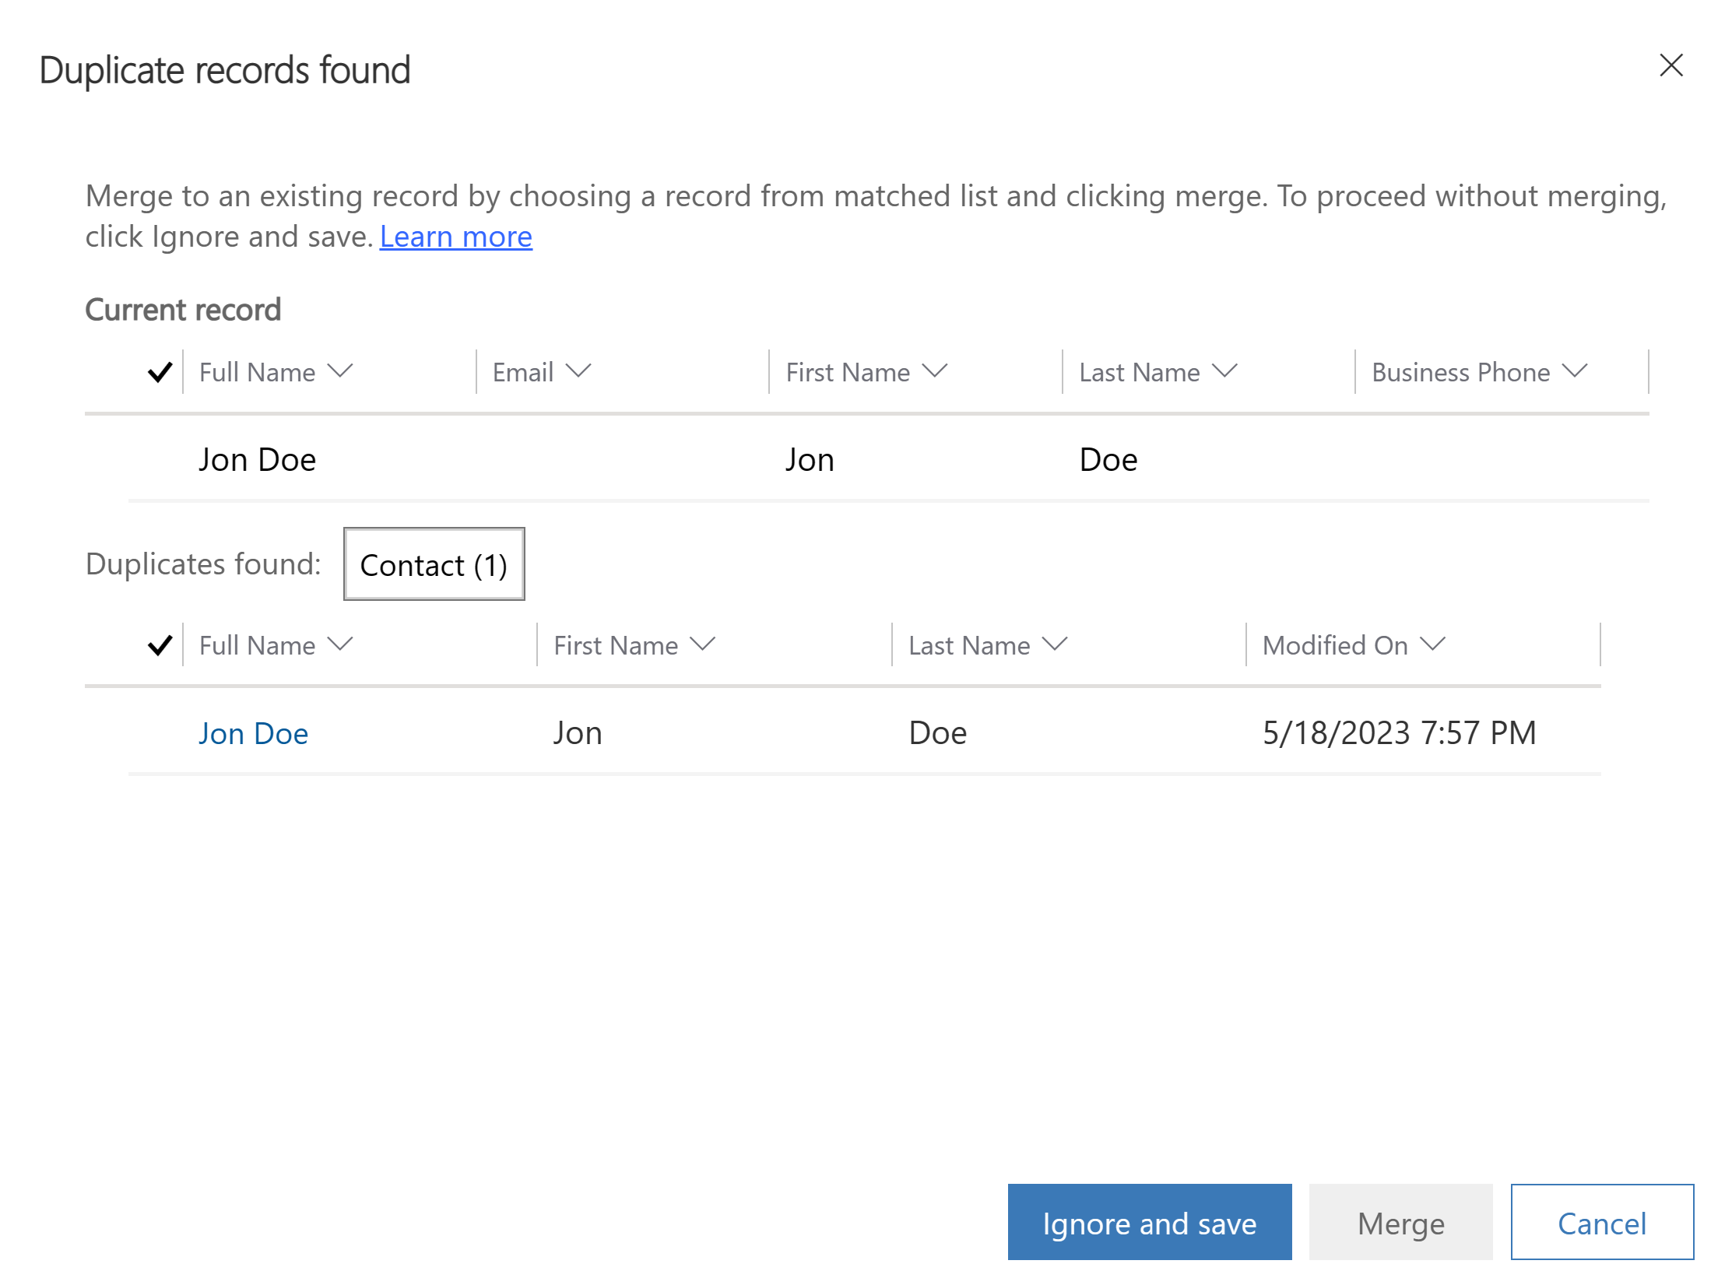

Click Ignore and Save, now you will notice the custom error message

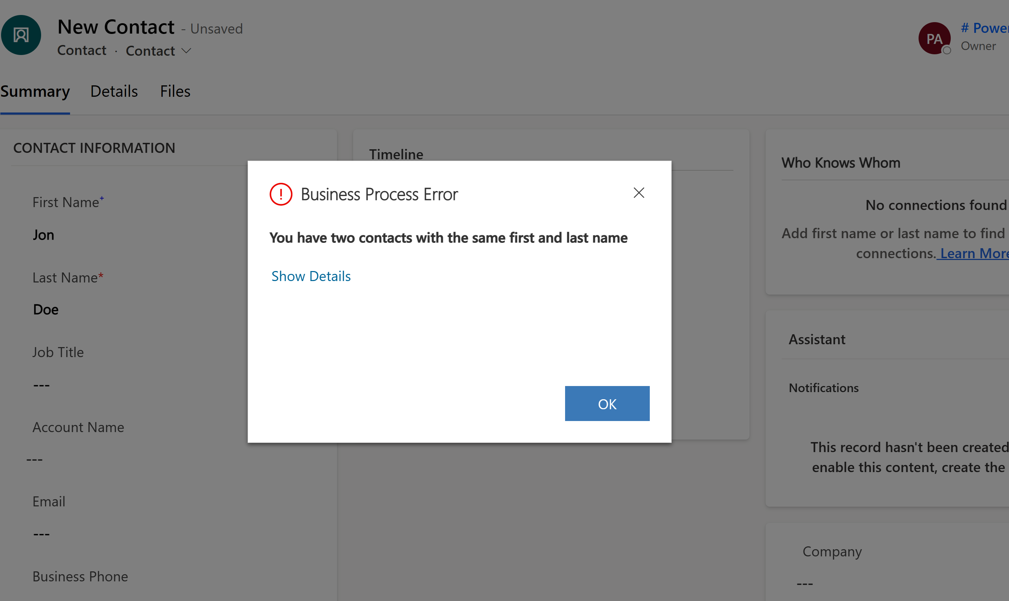

# Advanced Scenarios

# Lab 3

## Invoke stored procedures from a Canvas App

In this lab you will need your Dataverse environment and App from Lab 2, and your SQL environment that contains your data tables and stored procedure. We will be creating a virtual action that will invoke an existing SQL stored procedure.

## Scenario

Contoso Solar Panels currently has a stored procedure they use to identify the best technicians for the installations. They use this because it’s a complex calculation that was time consuming to handle manually and they couldn’t easily handle it in their excel file. They use the customer’s zip code, the service they want to have done, and the times they would prefer to have the service to determine which engineer is in their area, with the skills and available during those time slots. It then selects the best engineer. Currently since this is a stored procedure, they previously had to rely in scheduled runs from IT to provide the outputs which were manually entered into the Excel. But, now she can create a virtual action for the stored procedure that will let the scheduler invoke it right in the app and get real time results. This will greatly decrease the overhead and time to complete installation setups.

## What is a Virtual Action Stored Procedure?

### Stored Procedures

SQL provides an action known as a stored procedure. This is one or more transactions statements, or .Net commands that are used to execute complex processes. These processes can accept inputs, provide statements that perform operations on the inputs, and produce an output or return value.

Stored procedures are used when complex processes or data needs would be better served being computed at the server level than in the client like power Apps. This improves the performance of the calculation and provides many more complex operations than would be available in a Power App.

In most cases stored procedures are executed in SQL by IT manually or by using automated triggers. This can cause a burden on IT and a bottleneck for getting needed information.

However, Dataverse can now be used to directly invoke stored procedures using a Virtual Action.

## Actions, Custom Actions, and Virtual Actions

Dataverse has a number of built in actions that provide synchronous “real-time” events and workflows that developers can use to quickly complete a desired task, for example the Email action will trigger the synchronous sending of an email when invoked as part of a workflow or other method. While there are a variety of actions available to developers, sometimes they feel the need to create Custom Actions.

Custom Actions allow developers to create their own actions that meet their needs that can be invoked by Power Apps and other clients within the Power Platform. Developers write custom actions which are stored within Dataverse. These custom actions can then be consumed just like the out of the box actions within the organizations they belong to.

Virtual actions are like custom actions, as they are not out of the box, but the action code itself exists in another source, in this example, SQL. The benefit of a virtual action is that it can be invoked by the system without having to recreate the action in Dataverse. Additionally, it allows you to execute actions where the data is stored providing better performance.

Virtual actions can be created to invoke a stored procedure from within a Power App. A virtual action can be created using a wizard which will step through the process of creation. You will need to know information ahead of time as you will need to be able to:

* Select or create a connection to the appropriate SQL server and database where the stored procedure is located
* Know which stored procedure you wish to use
* What inputs and outputs are required by your procedure

## Power FX and Virtual Actions

Power FX is the powerful formula language provided with Dataverse that allows users to create formulas to achieve many different things within an app. They can perform calculations, define actions, and more. PowerFX will be used when creating your custom action. The wizard you are using will provide a streamlined interface that will construct your Power FX formula for you.

# Create the Virtual Action Stored Procedure

1. In the Power Apps Maker Portal select Dataverse Accelerator from Apps
2. In the Dataverse Accelerator, click on New Action in the Virtual Actions box.
3. You will be asked to name your plugin and provide a description, then click Advanced Options and click on Launch Plugins Wizard
4. Pls use your own SQL Server login

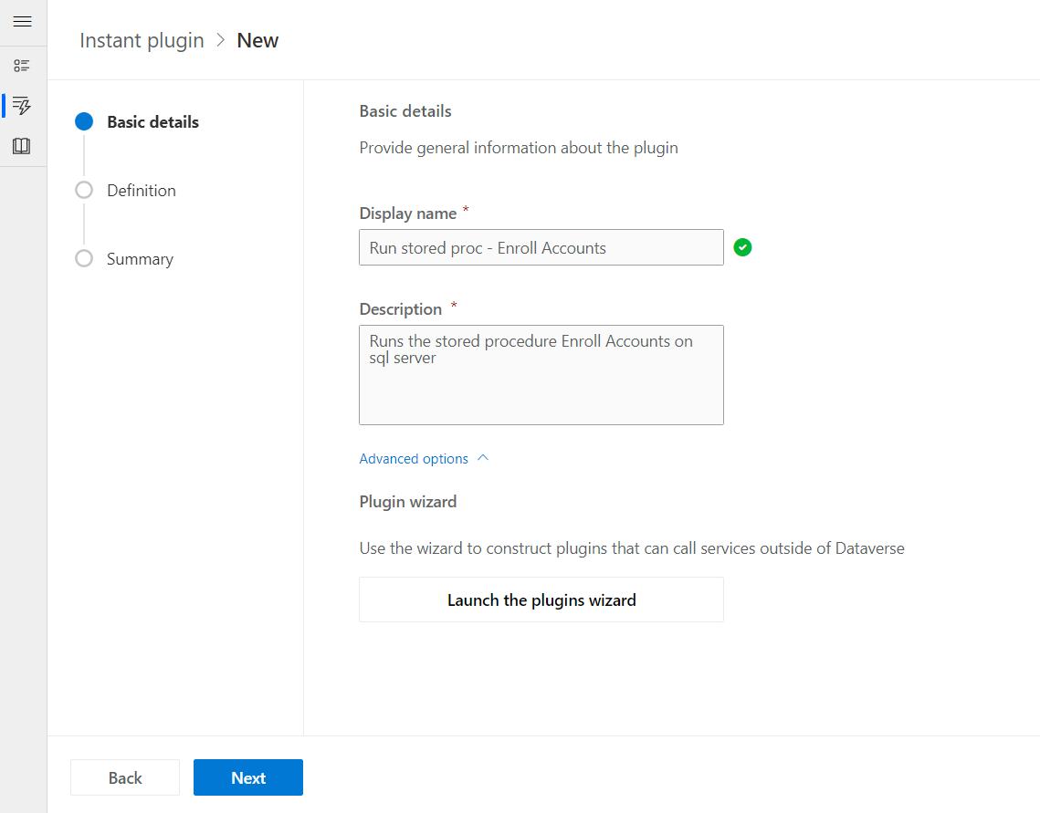

1. You will be presented with a connections screen, any SQL connections you already have configured for your organization will appear here. If the connection you need is already present you can select it and skip to step <6>.

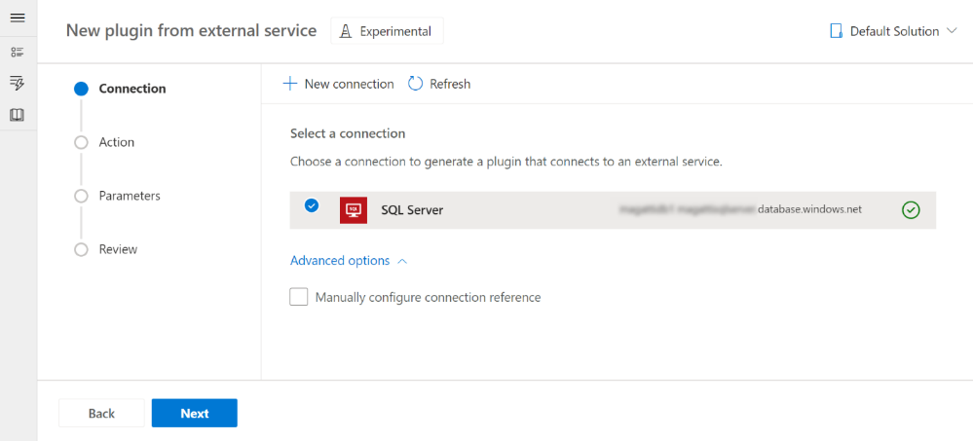

Otherwise click New Connection or Add connection

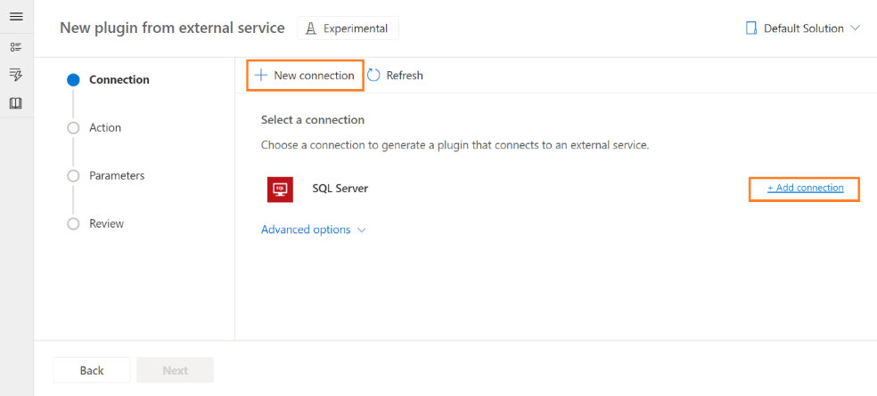

1. You will be asked for your SQL authentication type, credentials, and other necessary information. Complete the required fields and click Create

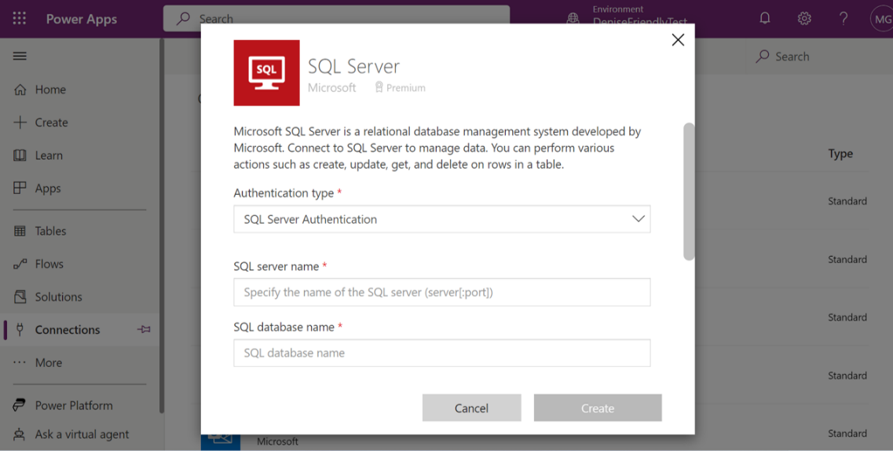

1. When your connection is created, return to the wizard and select your connection from the connections list and click Next

Note: Connections use a Connection Reference to interface between Dataverse and the data source you are connecting to. The connection reference will be created for you, but if you would like to be able to provide a custom name, you can do so by selecting “Advanced options” and opting in to Manually Configure Connection Reference. This can also be used to select from existing connection references for an existing connection.

If you choose to manually configure, you will be able to select an existing connection reference or supply a name and then click Next.

1. A list of available SQL actions are provided, this allows you to pick which SQL action you want to create a virtual action for. In this case we are using Execute Stored Procedure, select the action and click Next

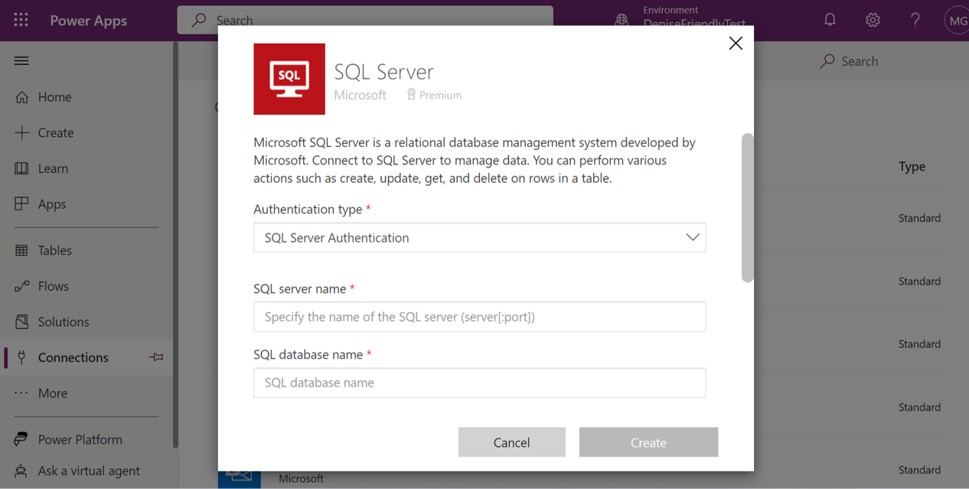

Note: For now only execute stored procedures is available.

1. In the provided dropdowns, select the values for:
   1. Server name – The name of the server for your connection
   2. Database Name – the name of the database on the server you wish to use
   3. Procedure Name – The name of the stored procedure you wish to use

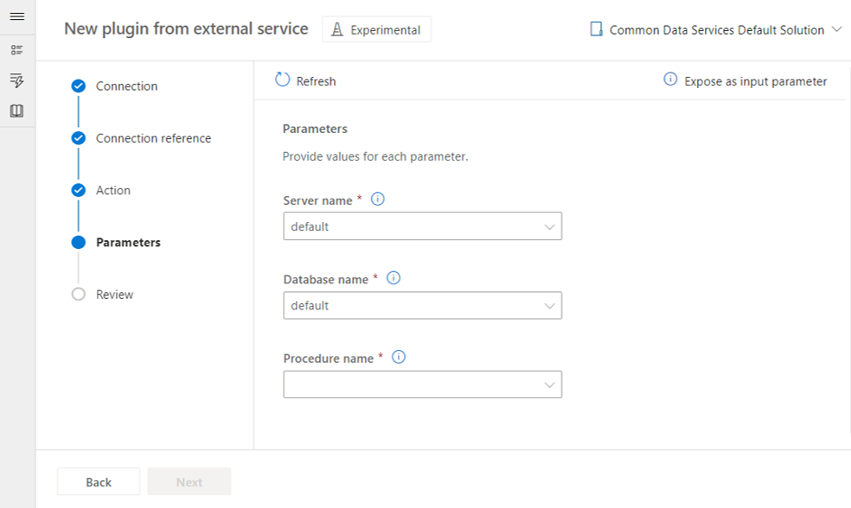

1. After providing values for the initial parameters available, a dynamic list of input values might be presented depending on the last parameter.   
   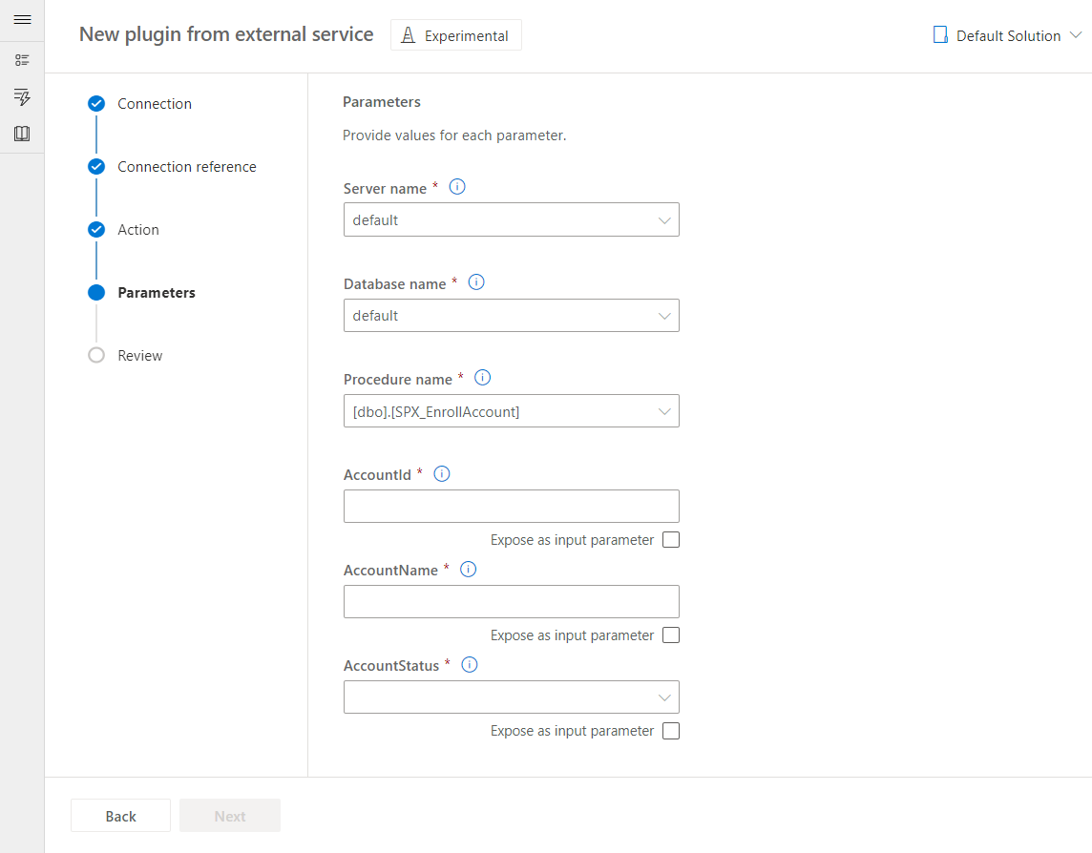  
     
   If dynamic values are returned, they can be configured in two ways:  
   1. **Input parameters**, which allow you to change the value every time the plugin is run. Check the box below the parameter to expose it as an input parameter.
   2. **Static values**, which stay the same every time the plugin is run. Provide a static value by typing in the text field or make a selection from the dropdown.

Once every field has a value, the Power Fx formula to invoke the procedure is generated. Click **Next**.

Click Next

1. You will be provided a review page that will show you the Virtual Action you are bout to create for the stored procedure. If everything looks correct, click Generate Action.

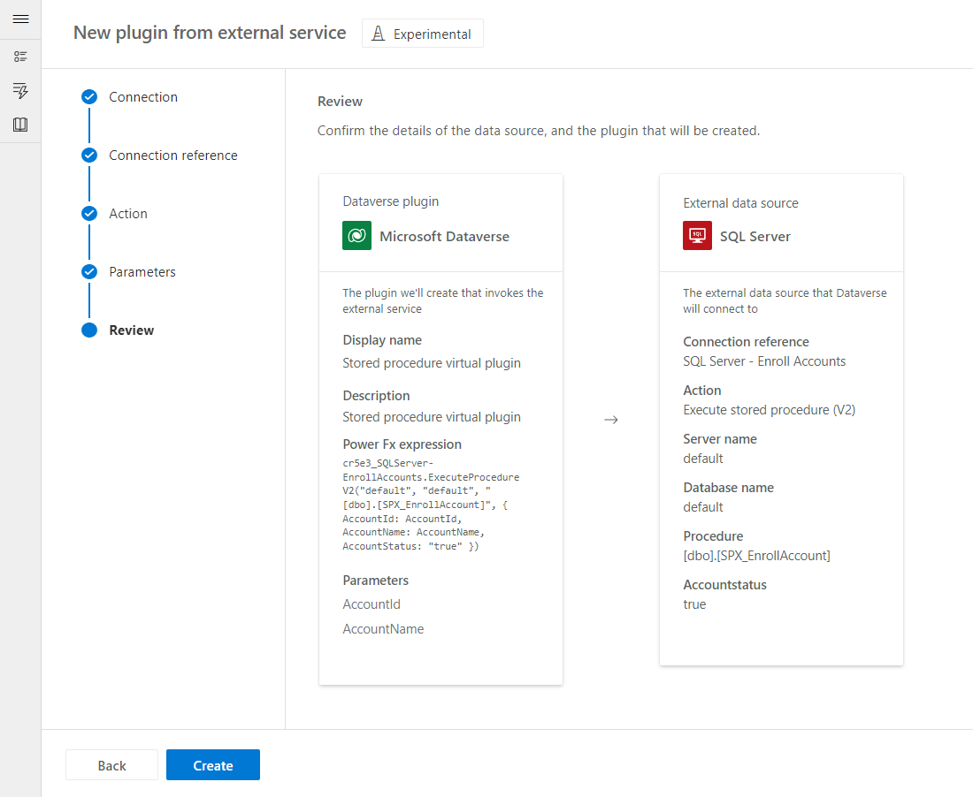

Your virtual action has been created!

1. You will be taken to the Virtual Action page which will show you any parameters that the stored procedure will be using. Each parameter that is expected will be listed and you can leave them as is, or configure them yourself. Each parameter will include:
   1. Label – the parameter name
   2. Direction – wither it is an input to the procedure or an output from the procedure
   3. Data type – what type of data will be used
   4. Required – This will indicate if the parameter must be populated or if can be left blank.

Note: If you require additional parameters than the ones listed, they can be added using the New Parameter button. This will insert a blank parameter row that can then be configured.

1. Formula – This is the PowerFX formula that has been generated for your stored procedure based on the wizard selection that have been made. This is the actual Custom Action itself. You can view and edit the contents of the formula here.
2. You can test the plugin by clicking Test
3. In the provided fields enter in sample data, this will be used to invoke the stored procedure. When the procedure is invoked you will be informed if it was successful or not.

In this example use:

* OrderID – 11099895
* SlotStartHour – 9
* CustomerZipCode – 95014
* Preferreddate – 3-29-2023
* Worktype – Installation of Solar Panel

Click Run

You will see a confirmation the stored procedure was invoked successfully

1. Once you are finished click Next.

Your Stored Procedure is now ready to use!

Next, see the Power Actions module on how to add your Virtual Action Stored Procedure into your app.

# Add your virtual stored procedure to your Canvas App

**Invoke the Low Code Plugin Stored Procedure with a button**

Once the low code plugin stored procedure is created you can then decide how to invoke it from within canvas apps. One good way to easily invoke it is by using a button on the app. Using the OnClick formula you can specify you want it to be executed and link the input values to existing fields.

To do this, you will need to know the name of the plugin you created, and also know the input parameters you set up. If you have forgotten you can look at your plugin’s details to get this information before you start.

To set the button to invoke the stored procedure:

1. Open the Canvas app you want to invoke the stored procedure plugin from
2. Click on the Data icon in the left hand navigation panel
3. Search for “Environment” and install the Environment data source. This is used for plugins, actions and other functions. It must be present to use the plugin.
4. Add a button onto the the app in the maker portal
5. Select the “OnClick” property and click in the formula bar
6. In the formula bar you will need to input a formula to:
7. Call the Environment data source – this is used to execute the plugins we have created
8. Specify the plugin you want to use
9. Identify which fields on the form you want to map to which input parameter.

Note: If an input parameter is configured to a static value and not a variable, that parameter does not need to be defined.

Formula Format: Environment.<pluigin logical name> ({

<<input parameter 1>>: <<form field 1>>. Selected<datatype>,

<<input parameter 2>>: <<form field 2>>. Selected<datatype>,

…

}

);

“Environment” is the Environment data source, which is used to call and execute plugins and actions from within Canvas Apps in Dataverse. After it is entered and selected enter the “.” You will then enter the logical name of your stored procedure plugin you created.

Input parameters are the individual parameters that are used as inputs to the stored procedure when invoking it. The must be one line for each input parameter. Then add the colon.

Form Field is the field on the Canvas App form that contains the data you want to pass. This is what provides you the ability to execute the stored procedure with any set of data from a record.

So for an example, if I had a stored procedure named “cr8b8_FindBestTech”, that had an input parameter of “customerZipCode” in SQL and my Canvas App form had a field named ZipCode, I would create it as

Formula Format: Environment.cr8b8_FindBestTech ({

customerZipCode: ZipCode.text,

}

);

The formula to populate the plugin is now complete. When you click on the button in the running app, it will take the input values from the fields specified, and pass them to SQL for processing. Then the stored procedure will process the data based on its configuration.

## Recap

Mona was able to create a virtual action for a SQL stored procedure that used to require IT intervention. Now from within the app the stored procedure can be invoked and the results automatically added to the tables where it is needed. This speeds up the installation appointment creation and reduces the overhead on IT.

# Lab 4

# Send in-app notifications with Power Fx

[In-app notifications](https://learn.microsoft.com/power-apps/developer/model-driven-apps/clientapi/send-in-app-notifications) enable makers to configure contextual, actionable notifications for users in model-driven apps. See [SendAppNotification and related action functions in Power Apps](https://review.learn.microsoft.com/en-us/power-platform/power-fx/reference/function-send-app-notification?branch=jaredha-fxfunctions) for more information on the Power Fx functions.

You can use the Dataverse Accelerator app to create a plugin that sends an in-app notification to a user. Note-You can create a dynamics trial at [Start a Free Trial for Microsoft Dynamics 365| Microsoft Dynamics 365](https://dynamics.microsoft.com/en-us/dynamics-365-free-trial/) to use the Sales Hub.

**Enable in-app notifications in the Sales Hub app**

In-app notifications are disabled by default, and are enabled for each app. To enable the notifications:

1. In the Maker portal, open the **Apps** list.
2. Select the **Sales Hub** app in the list, and click the **Edit** action on the action ribbon.
3. Click the **Settings** action on the ribbon.
4. On the **Features** tab, enable the **In-app notifications** setting, and **Save**.

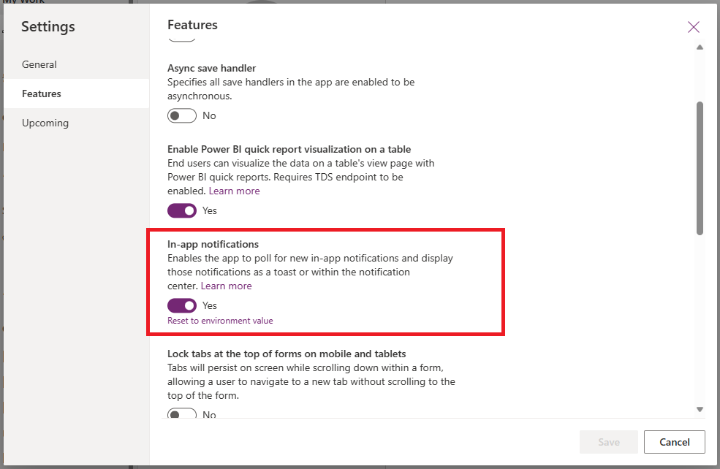

1. Select the **Publish** action on the ribbon to publish the change.

**Create an automated plugin**

1. Open the **Dataverse Accelerator App**.
2. Select to create a new **Automated plugin** with the following settings:
   1. **Display name:** Send in-app notification for new task
   2. **Table:** Task
   3. **Run this plugin when the row is:** Created
   4. **Formula:**

```powerapps-dot

XSendAppNotification( "New task assigned", AsType(ThisRecord.Owner, Users), "A new task has been assigned to you: " & ThisRecord.Subject, [XCreateSidePaneActionForEntity( "View task", "pane ID", "Your assigned task", "task", **Text(ThisRecord.Task)** ) ] )```

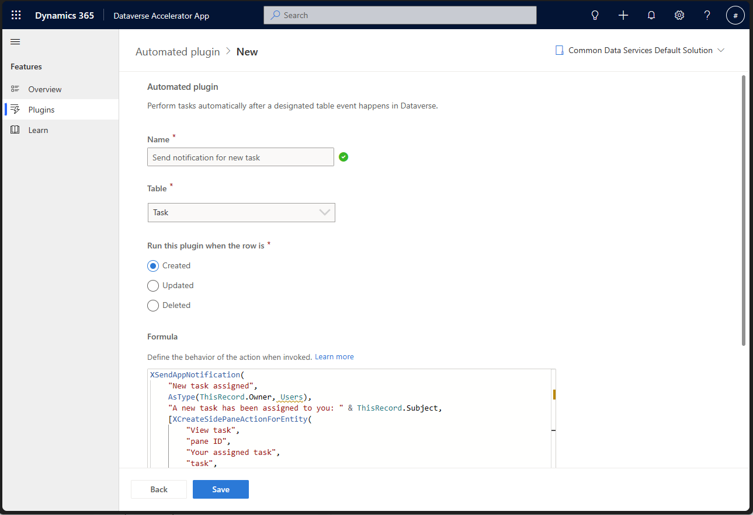

1. Click **Save**.

**Invoke the automated plugin**

1. Open the **Sales Hub** app.
2. Select the **Activities** tab.
3. Select **Task** on the action ribbon.
4. Enter a **Subject** and **Description**. (Note that your user is assigned as the task owner by default. The owner will receive the in-app notification.)
5. Click **Save & Close**.
6. Refresh your browser page.

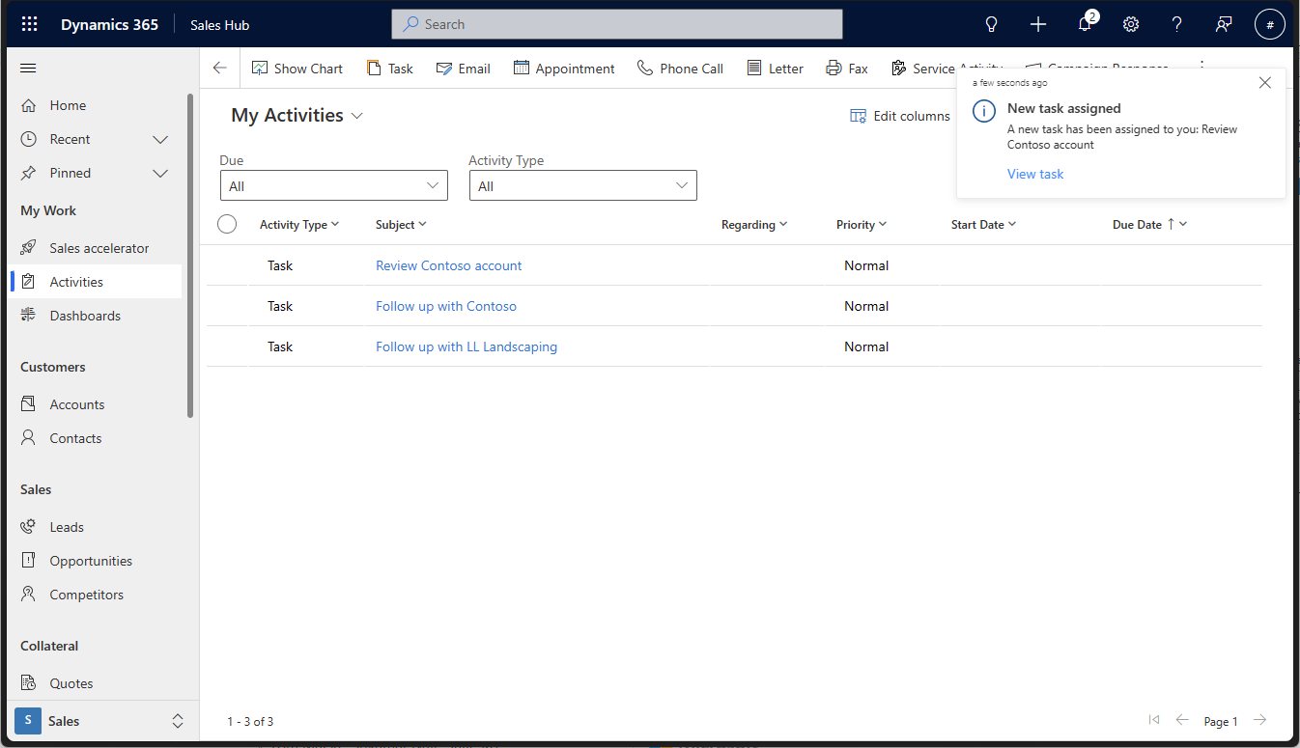

1. On the toast notification that displays, select the **View task** action.

# Lab 5

# Enable real time chat on orders and include the chats in the timeline

In this lab you will enable and use the Teams chat and timeline experience in Dynamics 365. You will need a Dynamics 365 environment with Sales installed, sample data is fine for the purposes here. You will also need a Teams environment and an account that has global admin access.  
  
Feature Overview  
Teams chat integration allows users to collaborate with colleagues via Teams chat while in the context of Dynamics 365 records and without having to switch between applications. One of the most common requests we have heard is that Teams chats should appear as an activity in the timeline of the related record(s). This is now possible with Teams chats as a new activity type. By synchronizing a limited set of metadata about the chat such as who last updated it and when, the position of a chat in the timeline will reflect the last time it was updated.

# Enable Teams chat and sync

1. Access the [Power Platform admin center](https://admin.powerplatform.microsoft.com/) as a user with the [Global admin](https://learn.microsoft.com/en-us/microsoft-365/admin/add-users/about-admin-roles?view=o365-worldwide#commonly-used-microsoft-365-admin-center-roles) role.
2. Select your environment.
3. On the command bar, select **Settings** > **Integration** > **Teams integration settings**.
4. On the **Microsoft Teams collaboration and chat** page, turn on the **Turn on Microsoft Teams chats inside Dynamics 365** and also the **Sync Teams chats with records** toggles.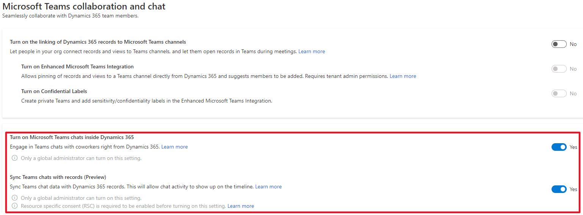
5. Save the changes.

# Create a new connected chat

1. Sign into the Dynamics 365 web application with any primary security role such as Salesperson or Customer Service Representative.
2. Open a Dynamics 365 customer engagement record such as an Account, Opportunity, Order, or Case.
3. Select the Teams chats and channels integration icon  at the upper-right of the page.

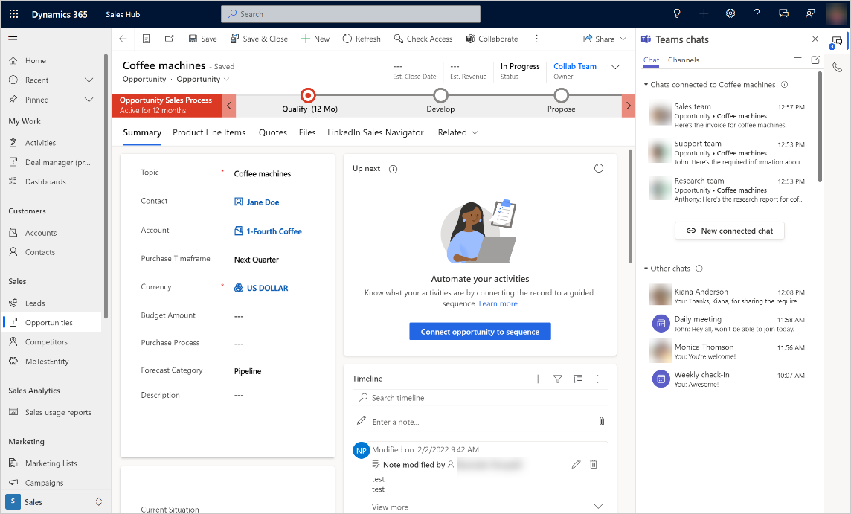

The Teams chat pane opens.

1. To start a new connected chat with a participant, select **New connected chat** in the **Chats connected to record** section.  
   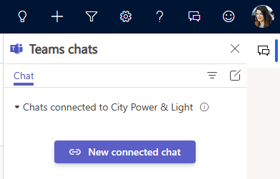
2. Use one of the following methods to add participants:
   * In the **Participants** field, browse and select the names of the participants you want to chat with.
   * A list of suggested contacts is automatically displayed for the **Participants** field. Select a participant's name from the **Suggested contacts** list. The **Suggested contacts** list displays the contacts of the users who are working on the record.
3. You can modify the chat name. It's a good idea to provide a meaningful name so that you can identify the chat even when you're in Teams.
4. Type a message you want to send to the participants.
5. Select **Start chat**.  
   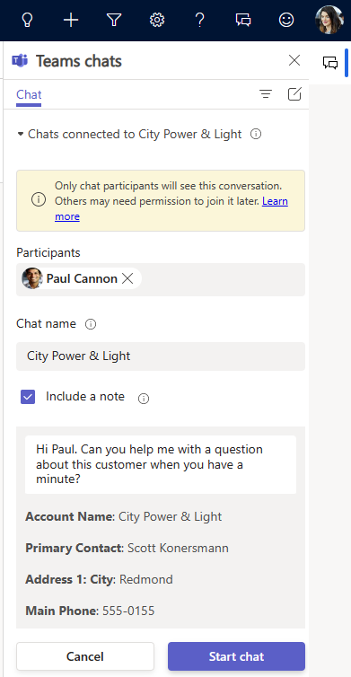  
     
   The participants you added to the chat will see the message appear in Teams.   
     
   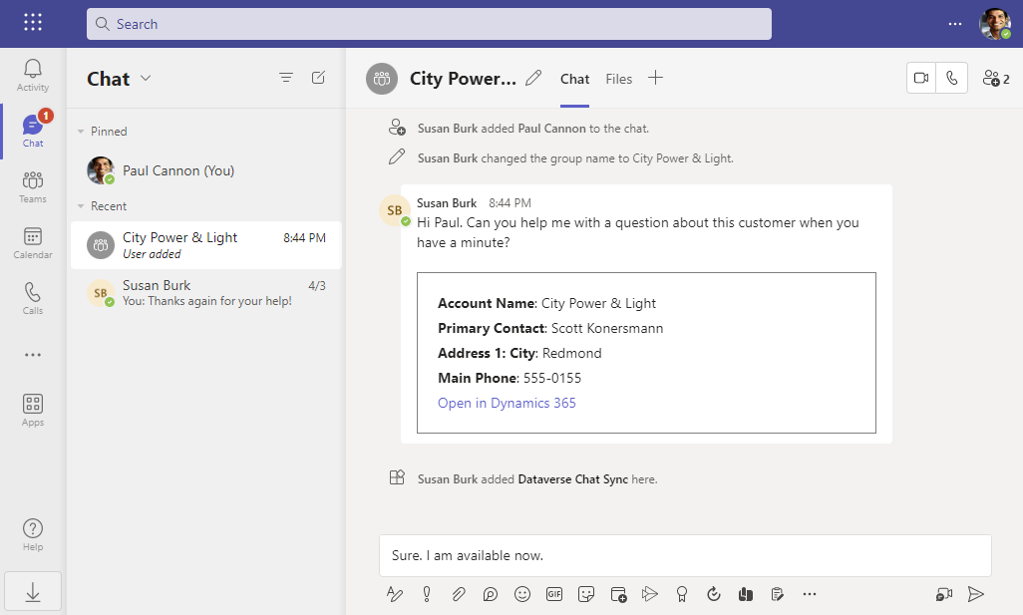  
     
   You will see an embedded chat control which allows you to continue the conversation from within Dynamics 365 without needing to switch apps.   
     
   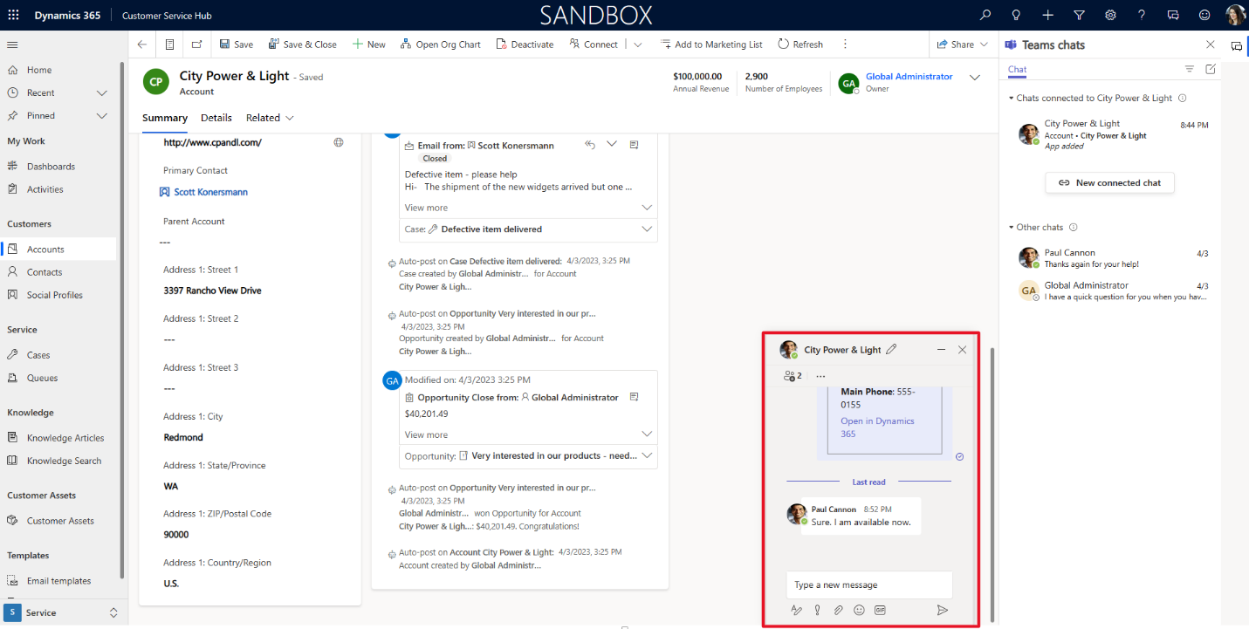
6. To test a reply from Teams, you can either reply as one of the participants using Teams or open <https://teams.microsoft.com/> in another browser tab and add a reply to the chat conversation. As shown in the screenshot above, the reply will appear in the embedded chat control in Dynamics 365.

# View the chat in the timeline

1. Refresh the data in the Timeline control by selecting the more commands option within the Timeline and then select **Refresh timeline**.  
   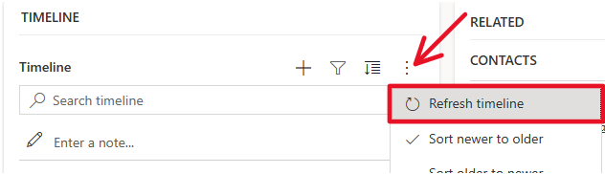

The connected chat was created as a Teams chat activity record which appears chronologically in the timeline just like other activity records such as emails, phone calls, meetings, and tasks.  
  
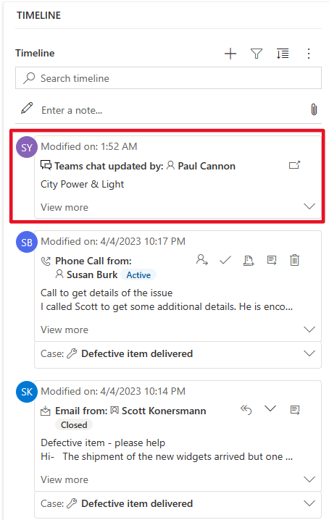

1. Select **View more** to see additional details such as who connected the chat and when as well as who updated the chat and when.

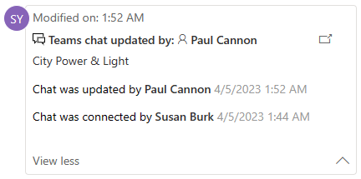

1. Close the embedded chat control if it is still open.
2. Click the open chat option in the timeline.   
   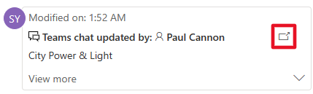  
   The chat appears within the embedded chat control allowing you to view or continue the conversation.  
     
   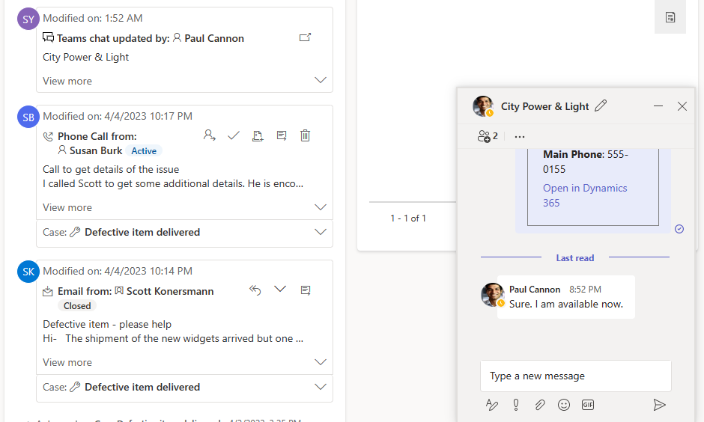

## Recap

In this lab you learned how you can collaborate with colleagues via Teams chat from the context of a Dynamics 365 record without having to switch apps. The connected chat was created as a new Teams chat activity record which can be viewed chronologically with all the other activities in the timeline.

# Lab6

## SendEmail upon Order Creation

## Scenario

Mona has the data in Dataverse and an app, she wants to use some of the components available in Dataverse to enhance the app. She wants to automate her business processes, so using Automated Lowcode action, she can now automate sending “Thank you for your order” email whenever a new sales order is submitted. The plugin that Mona will be authoring is a Business Rule that states ‘Generate Thankyou Email every time when a new service order is created’. The service order table was created by the Excel2APP lab we performed above. Since this is an event based plugin, you will have to manually add an order record and verify if an email is generated.

## Set up an Automated Lowcode plugin – Send an automated email upon a dataevent

1. Launch Dataverse Accelerator app 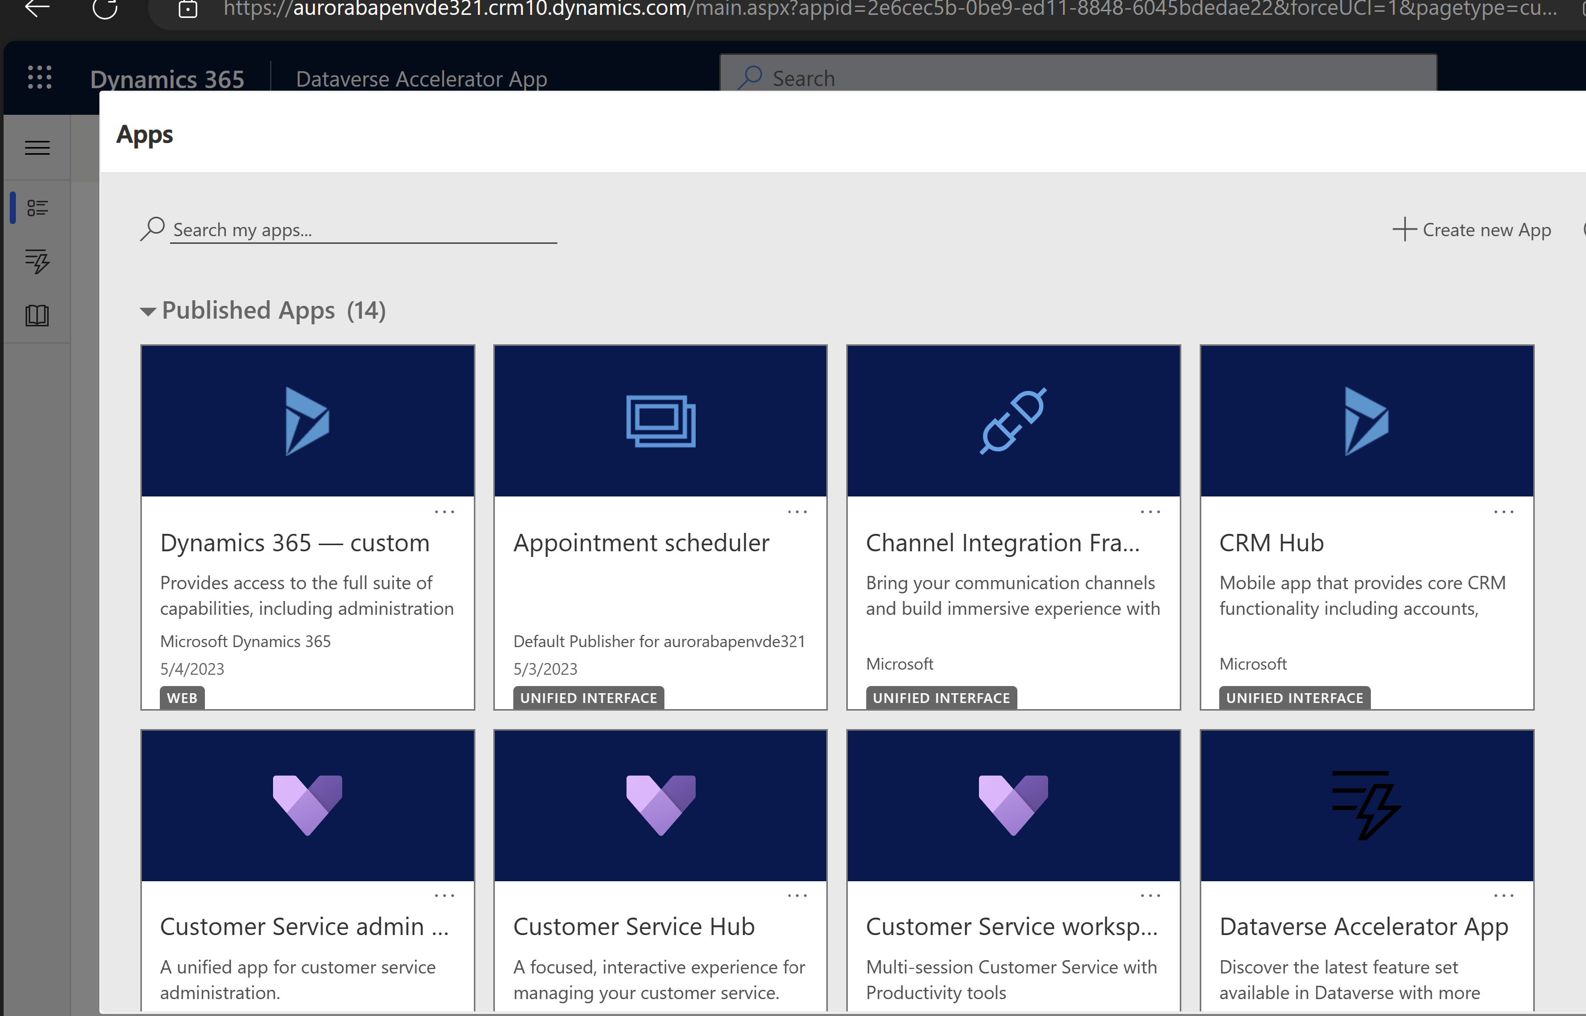

2.Click on ‘Dataverse Accelerator App’ > Click on Automated plugin >+New plugin

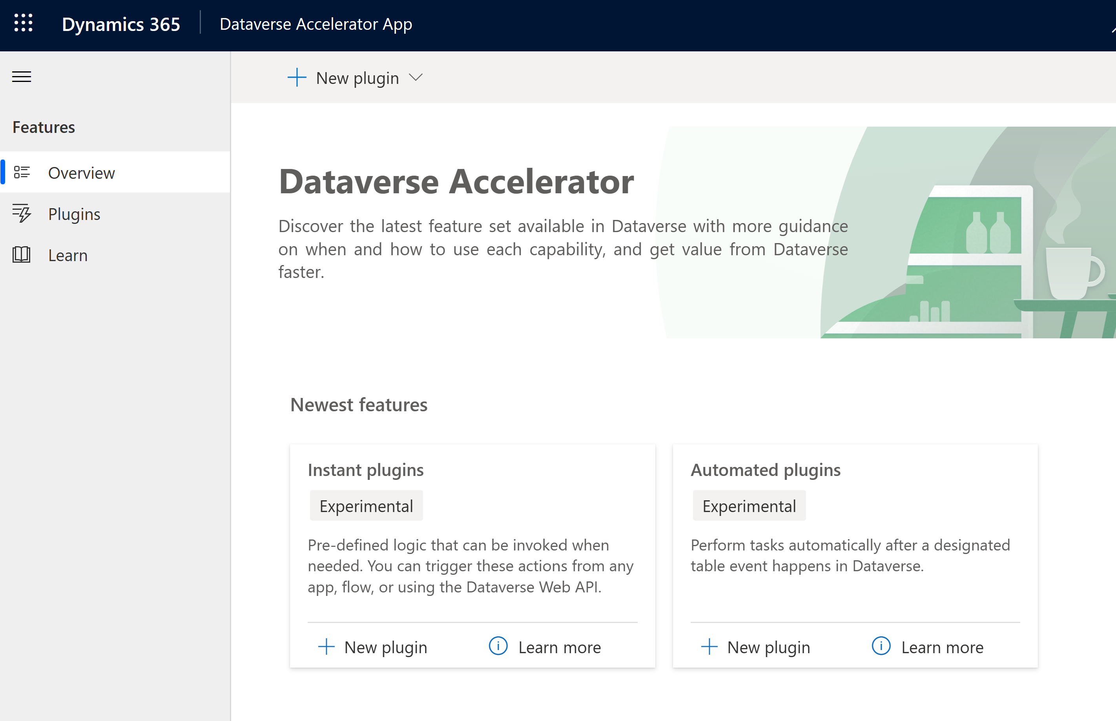

1. Enter Name- SendEmailOnOrderCreate

Table:Select the logical table name of the Service Orders. Because this event is based off of Service order table, we will set the context of this table below.

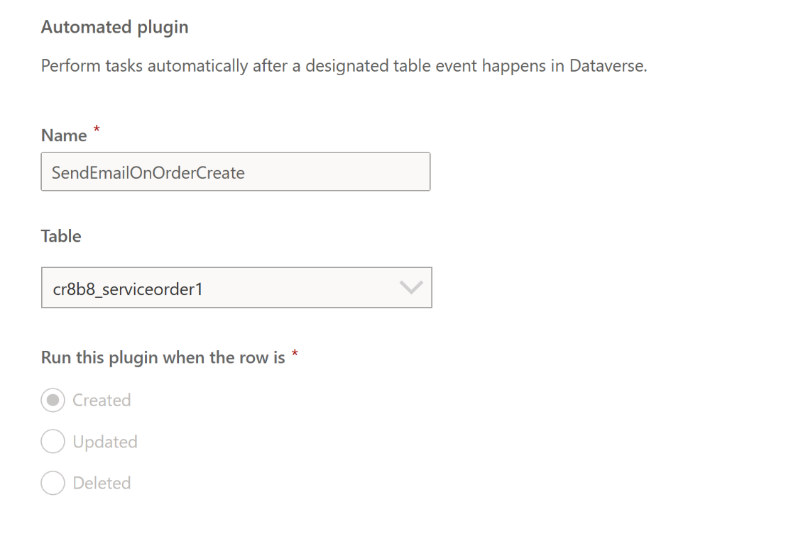

Run this plugin when the row is : Select ‘Created’ , because everytime when a new sales order is created, you want to send Thankyou Email

4.Enter this Fx expression under the ‘Formula’ section:

XSendEmailFromTemplate(LookUp('Email Templates',StartsWith(description,"solar")).'Email Template',ThisRecord,LookUp(Users,'Primary Email'="xx@xx.com "),[ThisRecord.Email])

!Note: that you need to replace with your primary email address from your environment

Here we have introduced a new function called ‘XSendEmailFromTemplate’ that will enable you to lookup email templates & send under the context of the user.

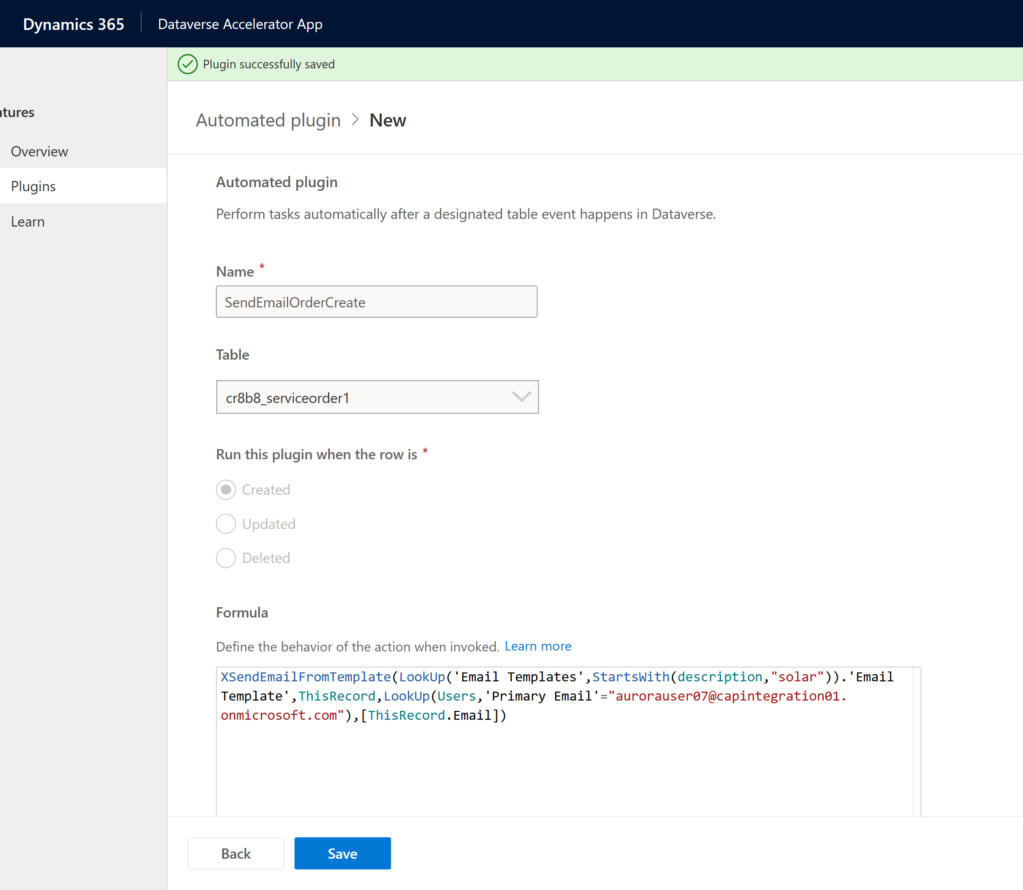

5.Now you need to simulate a data event, let’s go the Canvas app and create a manual order. Go to Home page of the maker portal [Power Apps | Apps](https://make.preprod.powerapps.com/environments/6a2888b8-34ed-e91a-818c-cfe43be91d42/apps)> Click ‘Apps’ on the left hand side of the page > Click on Service Order app

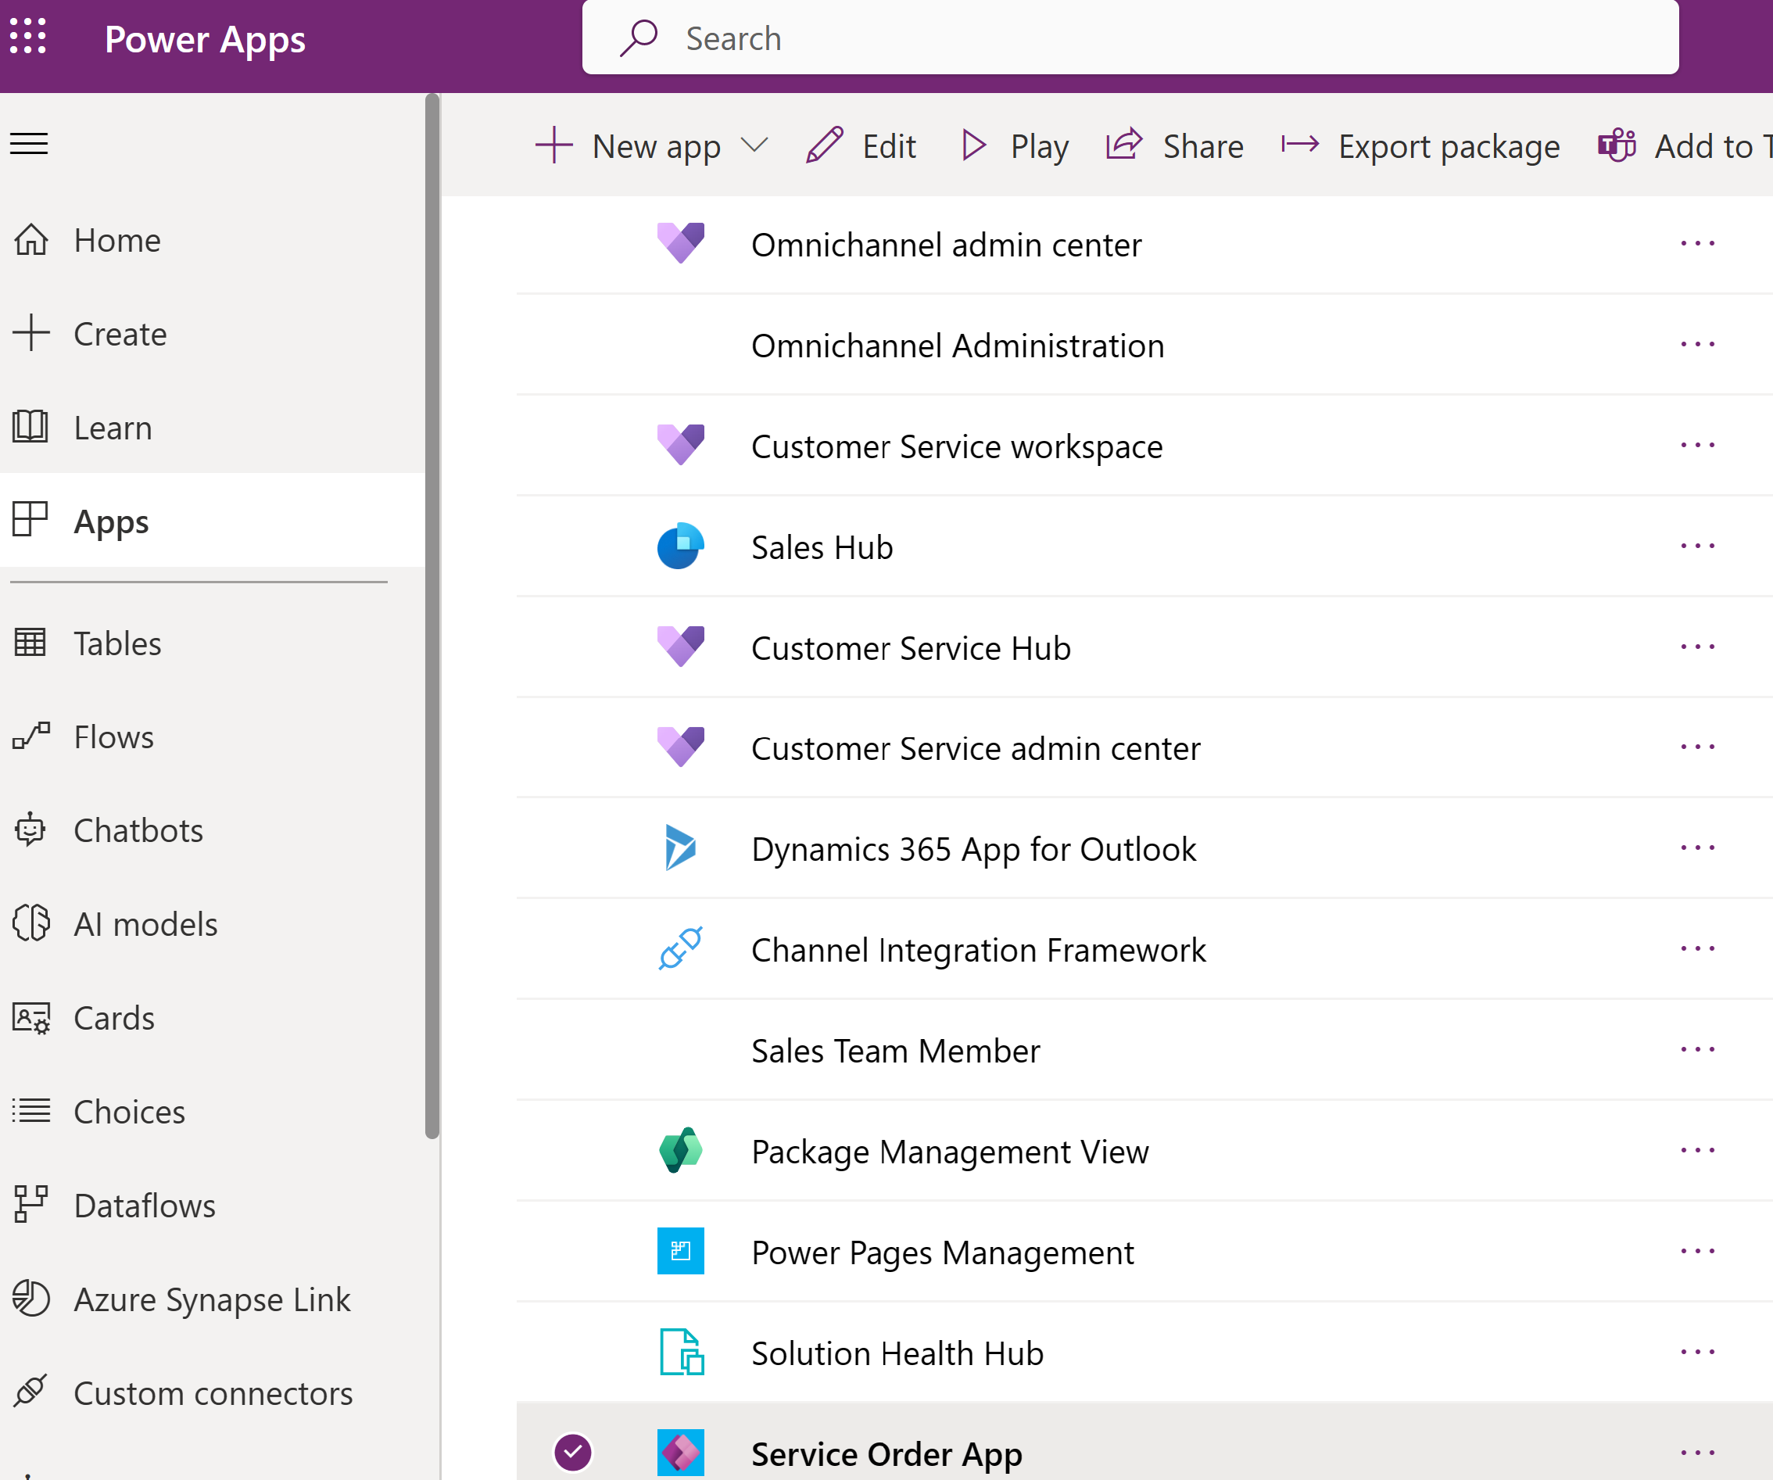

6.Create a manual order from the app to check if the Email gets triggered upon Sales order creation. Click on ‘New record’

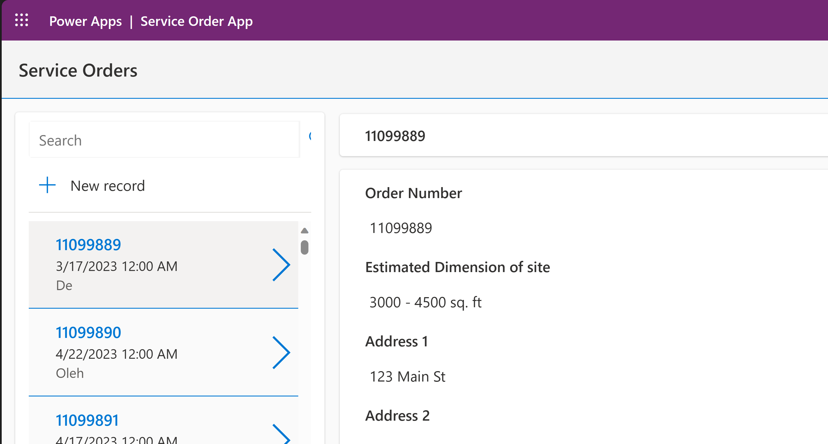

7.Enter order details in each field and hit the green tick mark, which will Save the record. The order number must be successfully saved on the left side of the page as indicated. Make sure the Order date is today’s date.

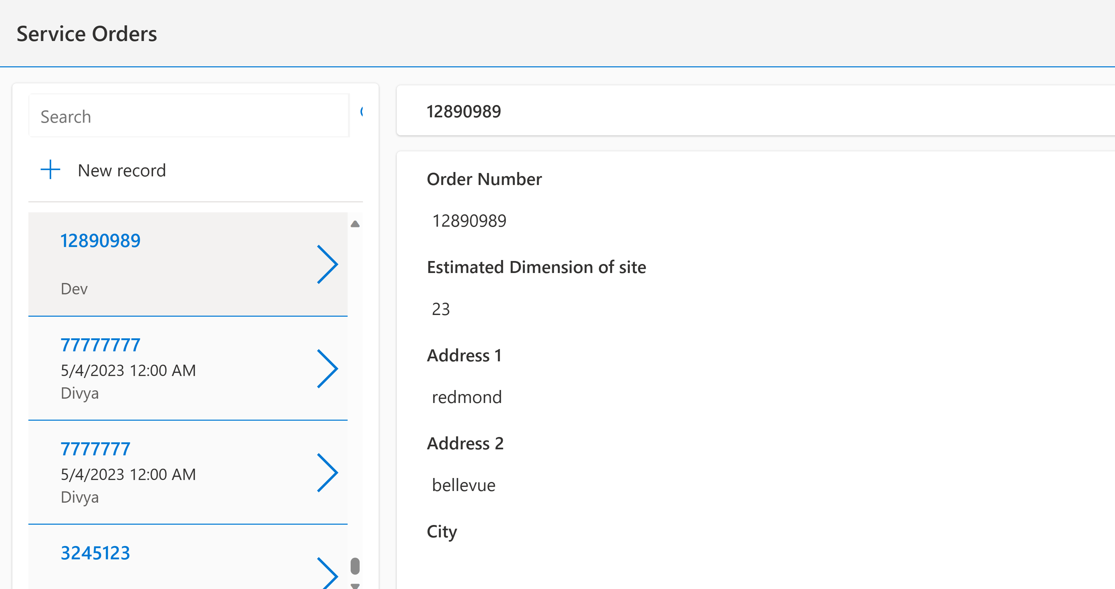

8.You can verify if the email is generated by logging into Make portal >Click Settings>Advanced Settings

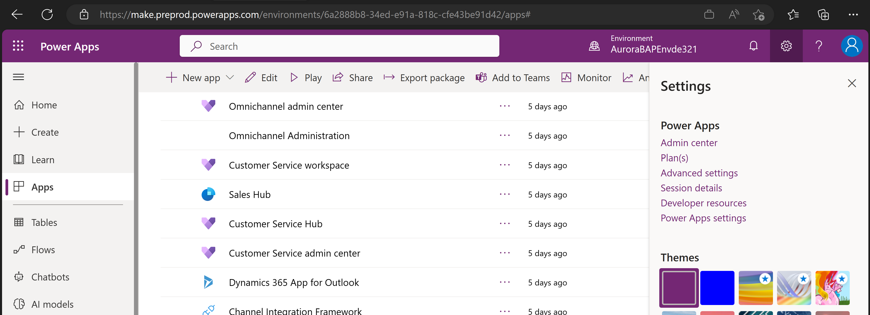

9.Wil take you to this page, Click ‘Advanced Settings’ > Apps>CRM Hub

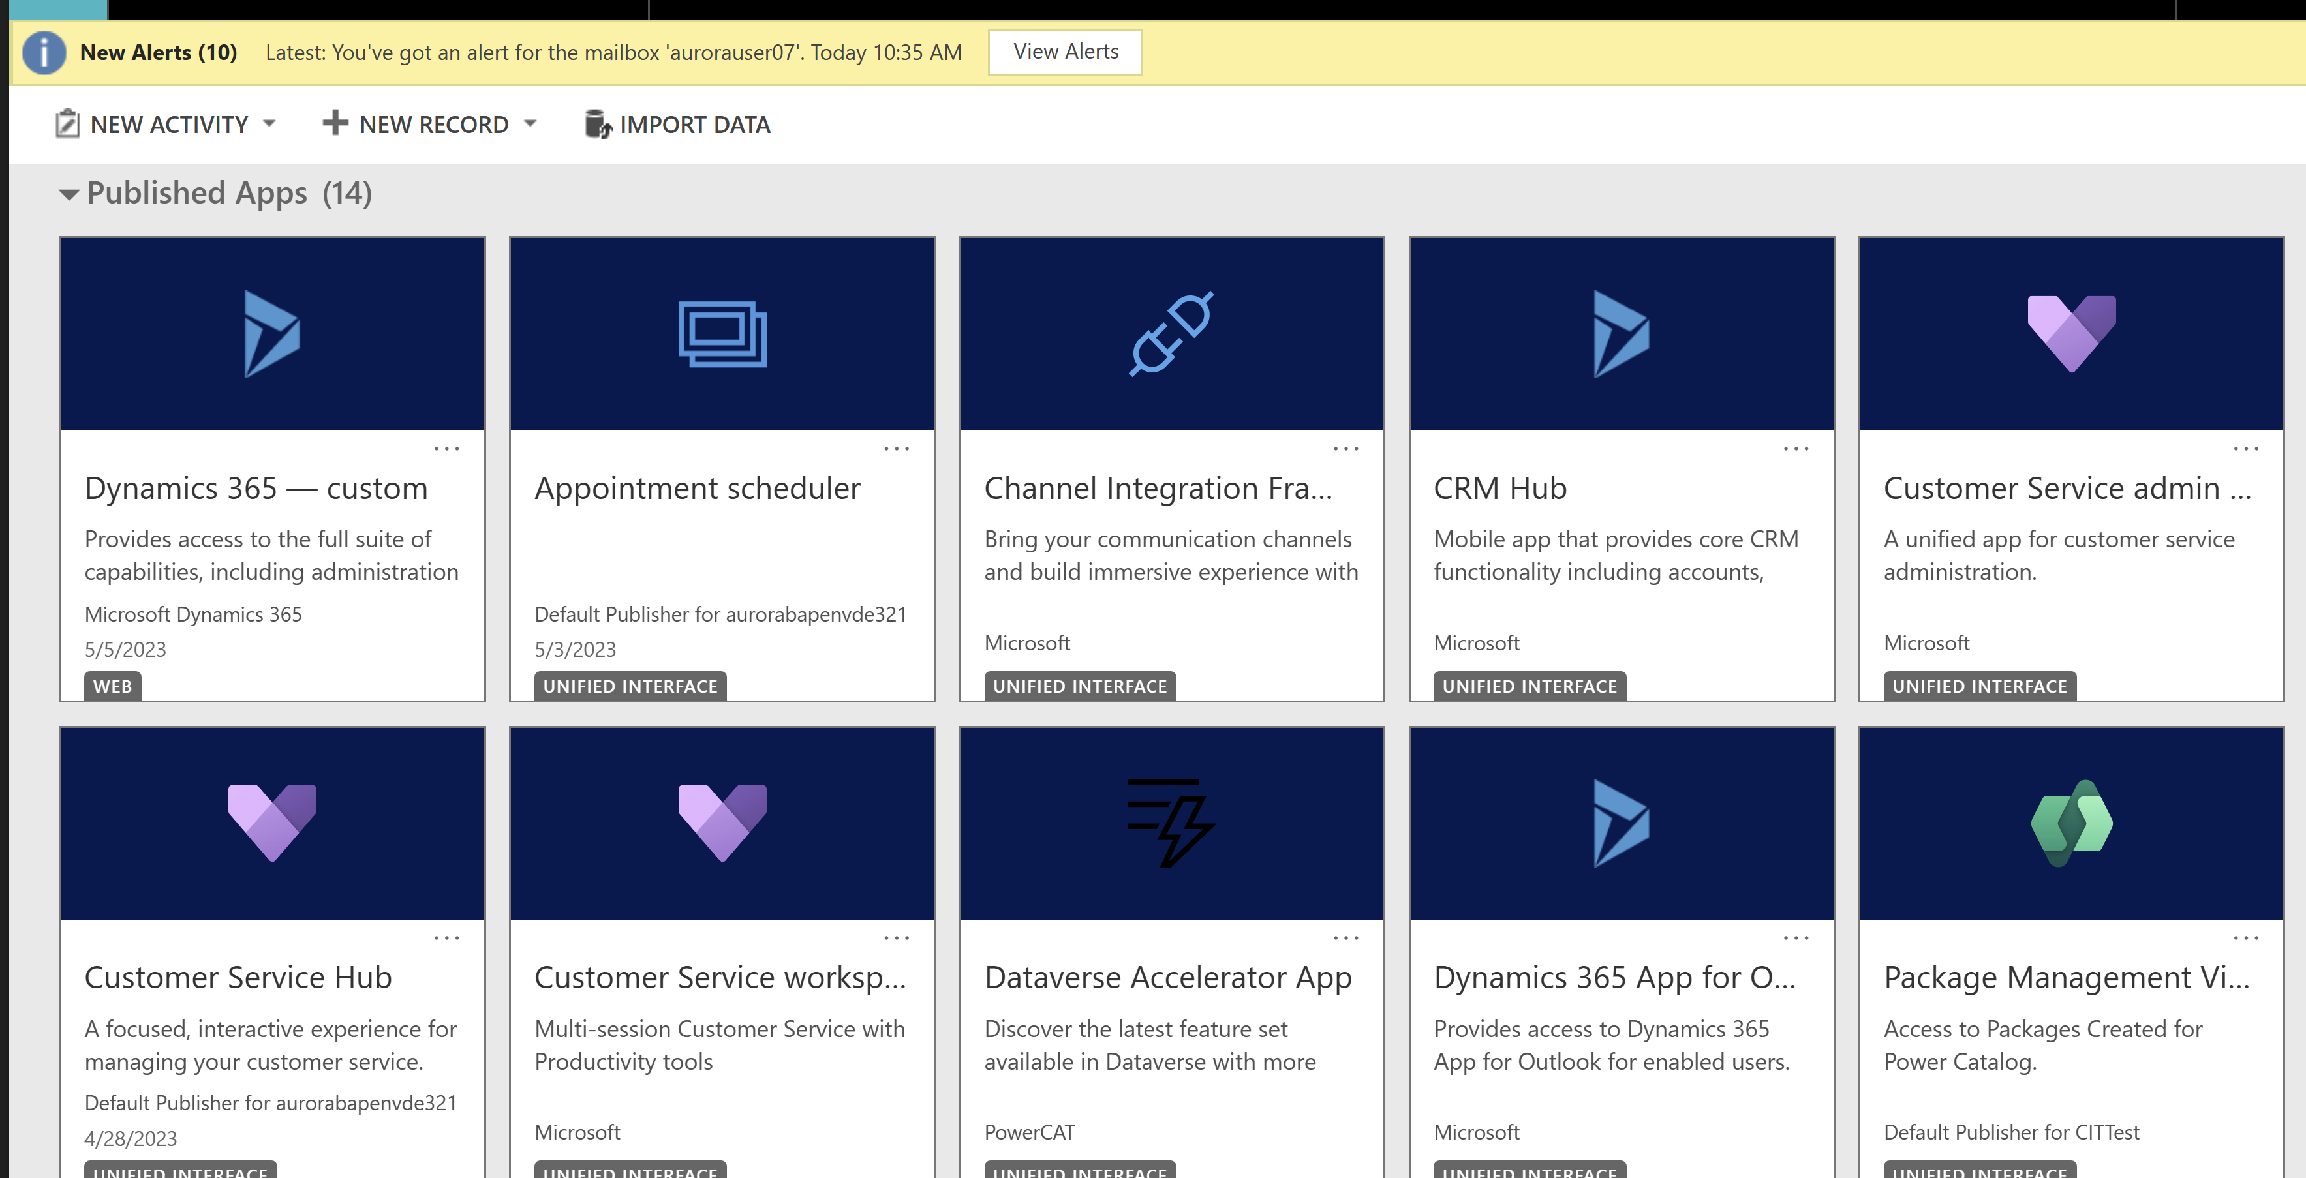

10.Select ‘All Activities’

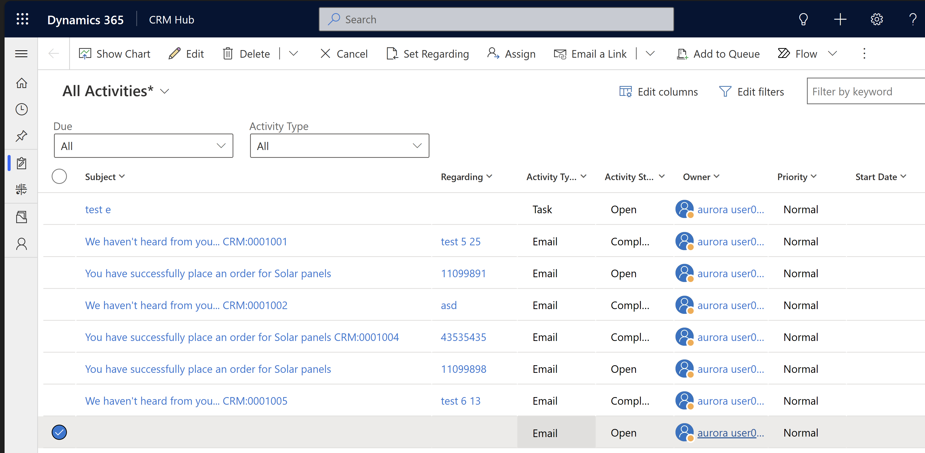

11.Click on the email to see the output . You will notice the order values are populated in the email.

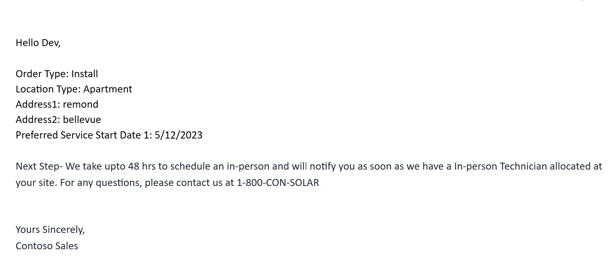

## Recap

Here we demonstrated how Mona was able to automate her sales process and send timely acknowledgement to her customer.